Awards to NGOs in India:
- Foundation for Ecological Security (FES)
FES has been awarded the Global Challenge Award on Inequality 2025 by International Land Coalition. The award was presented on the 19th June 2025, during the Global Land Forum, held during 14-19th June 2025, in Bogota, Columbia.
FES received this honor in recognition of our work with local institutions to strengthen collective management of Commons, and our efforts to bridge the gap between policy and practice.
This recognition is an important milestone for highlighting the criticality of community-led Commons governance for reducing inequalities and building a climate resilient, just future for all. We are committed to supporting solutions that emerge from the ground-up, and grateful for the diverse collaborations that make it possible.
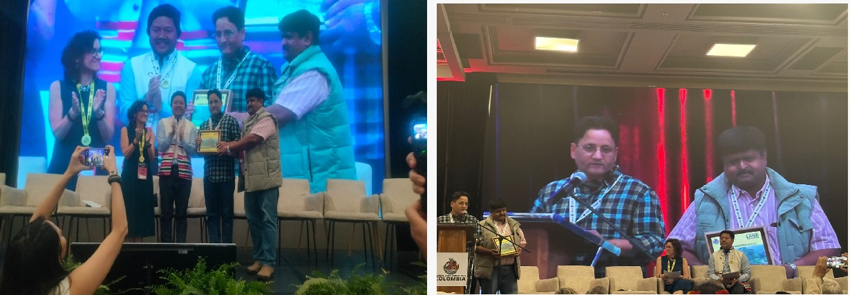

- KRAPAVIS
KRAPAVIS from Rajasthan received "ELINOR OSTORM AWARD 2025" for its outstanding contribution to the commons. This prestigious global Elinor Ostrom Award is given by the IASC (International Association for the Study of the Commons).
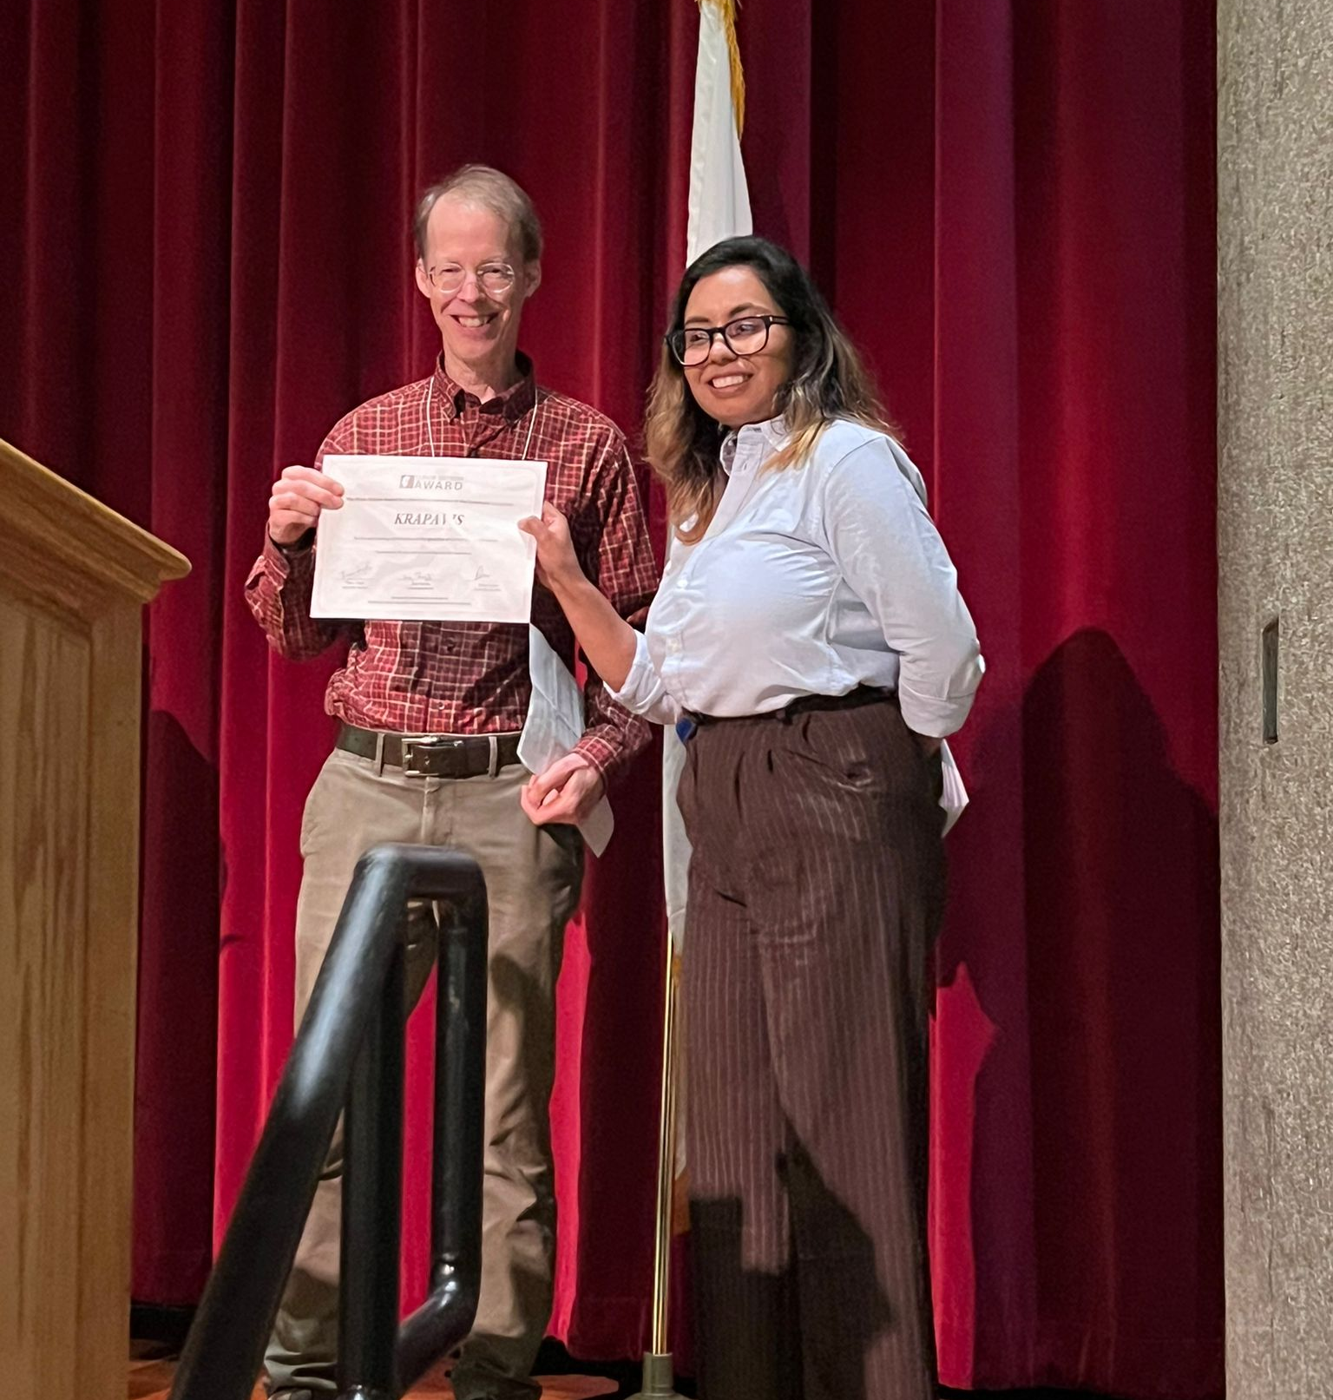

Information provided:
P. Vivekanandan, International Year for Rangeland and Pastoralists 2026, RISG – South Asia.

