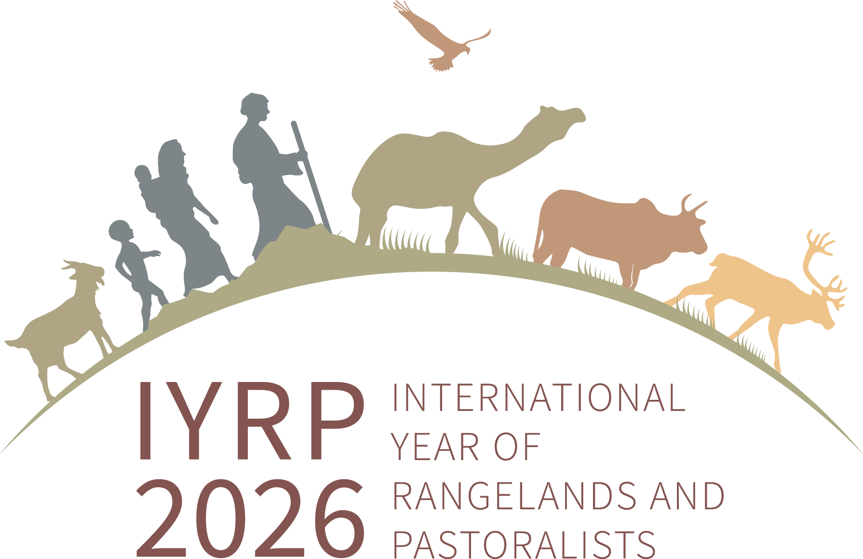

IYRP 12 global monthly themes - 2026
A flexible framework for integrated and coherent global advocacy
during each month of 2026.
For details see: https://iyrp.info

Month | Theme | Main messages
January | Rangelands and pastoralists: a global overview | Who are pastoralists? What are rangelands?  Pastoralism is not nostalgia but a sustainable future.  Sustainable and equitable governance and management are key to thriving rangelands and resilient pastoralists.
February | Mobility, land and water security | What is pastoral mobility?  Pastoral mobility is essential for rangelands and pastoralists and must be accommodated within land tenure and water resource laws.
March | Livelihoods and economics | Pastoralism is an economic powerhouse that is largely unrecognized.  Rangelands are not wastelands.  Pastoralists are food security champions.
April | Climate Change and resilience | Pastoralism is an integrated strategy to simultaneously tackle adaptation to and mitigation of climate change while enhancing the resilience of peoples.
May | Biodiversity and ecosystem services | Pastoral land management preserves biodiversity of rangelands and safeguards a host of ecosystem services.
June | Sustainable rangeland use and restoration | Pastoralists serve as custodians of rangelands and their practices help to conserve and restore them.  Stop indiscriminate conversion of rangelands to cropland and other inappropriate uses and prevent the abandonment of rangelands.
July | Services and infrastructure for pastoralists | Pastoralists need services and infrastructures compatible with and adapted to their ways of life. Improve access to health, education, financial, internet, and other services.  Create mobility corridors and landscape connectivity.
August | Indigenous and local knowledge, culture and innovation | Recognise, value and equally respect indigenous and local knowledge of rangeland management.  Help preserve knowledge and pass it down through generations.  Celebrate cultural diversity and conserve cultural heritage of pastoralists.
September | Benefits to society | Pastoralist traditions have provided many value systems and cultural identities in shaping our world. Rangeland products contribute to nutrition, health and hygiene; celebrate the diversity of these products.  Pastoralist production can make a significant contribution to global protein supply and meet rising demand for healthy food.
October | Pastoralist women | Promote gender-inclusive approaches, and the equitable and inalienable rights of pastoralist women to own and inherit livestock, access and use land, natural resources, biodiversity, technology, knowledge and information, and appropriate health, education and social services.  Ensure safe, non-discriminatory and violence-free workplaces for pastoralist women.
November | Pastoralist youth | The future of pastoralism will depend on the innovation and inspiration of future generations.  Address high entry barriers by enabling pastoralist youth to access land, participate in governance, and maintain their pastoralist mobility and flexibility.  Improve access to mobile schools and vocational training, entrepreneurship, and internet-literacy.
December | Innovative solutions for a sustainable future | Innovate in herd and rangeland management, beneficial technologies and infrastructure, economic , insurance and other services.  Recognise and promote pastoralists, including women and youth, to participate in co-production of knowledge and innovation.

