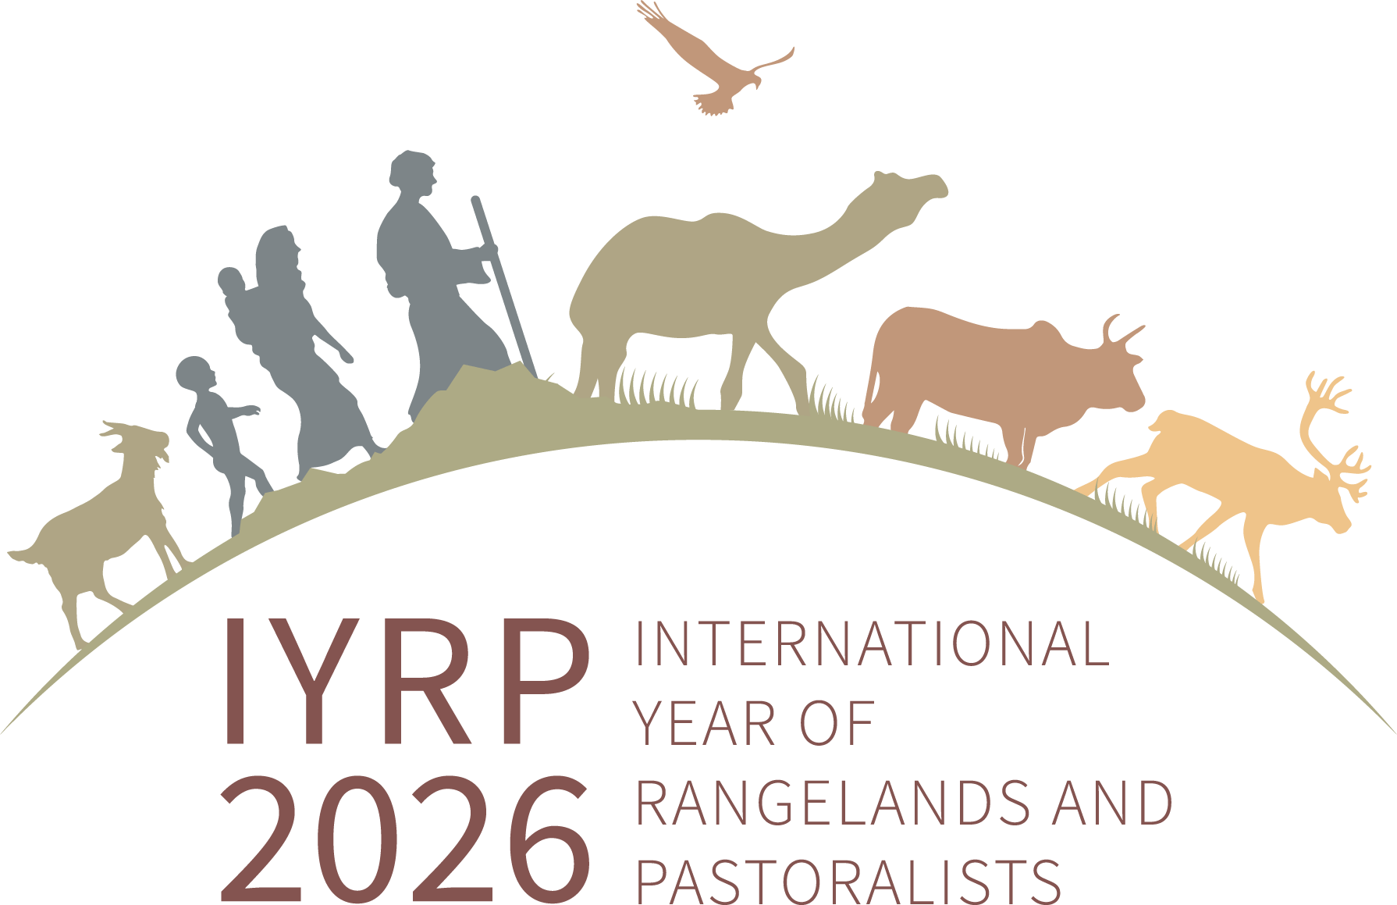

Members & email addresses of Global Secretariat of the IYRP Alliance (GSIA) (as of 1 August 2025)

(preferred name underlined)

# Co-chairs of the IYRP Alliance:

(Ms) Burmaa Dashbel, Mongolia [(d.burmaa.1@gmail.com)](mailto:(d.burmaa.1@gmail.com) Enrique Michaud, Peru [(enrique.michaud@gmail.com)](mailto:(enrique.michaud@gmail.com)

Igshaan Samuels, South Africa [(isamuels@uwc.ac.za)](mailto:(isamuels@uwc.ac.za)

# Working Group coordinator:

Jonathan Davies, UK [(jonathantilstonedavies@gmail.com)](mailto:(jonathantilstonedavies@gmail.com)

# Website and listserv coordinator:

(Ms) Barbara Hutchinson, USA [(barbarah@cals.arizona.edu)](mailto:(barbarah@cals.arizona.edu)

# Communications advisors:

(Ms) Lauren Svejcar ([laurensvejcar@gmail.com](mailto:laurensvejcar@gmail.com))

Abdul Wahid Khan, UK/Pakistan [(abdul.khan@ouce.ox.ac.uk)](mailto:(abdul.khan@ouce.ox.ac.uk) Engin Yilmaz, Turkey [(engin@yolda.org.tr)](mailto:(engin@yolda.org.tr)

# Senior advisor (former co-chair):

(Ms) Maryam Niamir-Fuller, USA [(mniafull2@gmail.com)](mailto:(mniafull2@gmail.com)