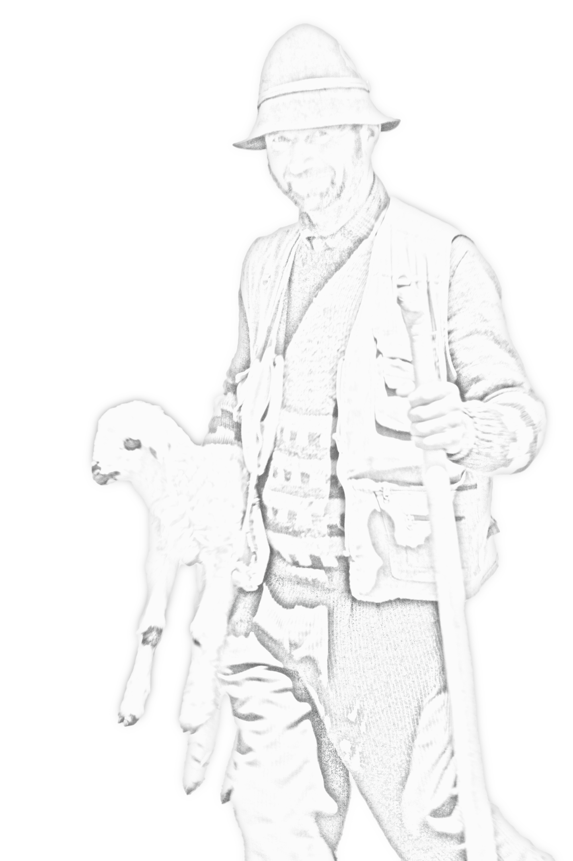
Animal Fibre Working Group – Concept Note (IYRP 2026)

Pastoral fibres – wool, alpaca, cashmere, yak, mohair, vicuña, camel and llama – are more than commodities. They are threads that connect herders, women, artisans and communities. While meat and milk often dominate attention, fibres create wider, long-lasting impacts: jobs, culture, biodiversity and sustainable landscapes.

Why Fibres Matter

Fibre economies multiply value far beyond direct sales. Women lead in processing, artisans transform fibres into products, and entire villages benefit. Recognising fibres alongside meat and milk gives a fuller picture of pastoral livelihoods.

The Challenges

Natural fibres face strong competition from synthetics, myths about grazing, animal welfare, and declining market value. Policies and tools like Life Cycle Assessment (LCA) often ignore the benefits of rangelands, the importance of well managed grazing for our cultural land and bias against natural fibres. New legislation, such as the EU’s Green Claims Directive, could reshape markets – but may also create risks if pastoral voices are not heard.

Our Objectives

- Highlight opportunities in fibre value chains and promote innovation that blends pastoral wisdom with modern technology.
- Show how fibres complement meat and milk, multiplying benefits for communities.
- Put rangelands at the centre of sustainability arguments.
Engage with policy and legislation to ensure fair recognition of natural fibres.
- Challenge myths by sharing evidence of fibre’s cultural, economic and ecological value.
- Represent diverse regional perspectives, from the Andes via Australia to Africa and from North America via Europe to Asia.
- Contribute actively to IYRP 2026 global activities and partnerships.

Join Us

We invite pastoralists, researchers, fibre specialists, NGOs and policy actors to collaborate. Together, we can make natural fibres visible, valued and vibrant – for pastoral communities, markets, and the planet.

Contact: Walter Aigner mail@montiola.com

