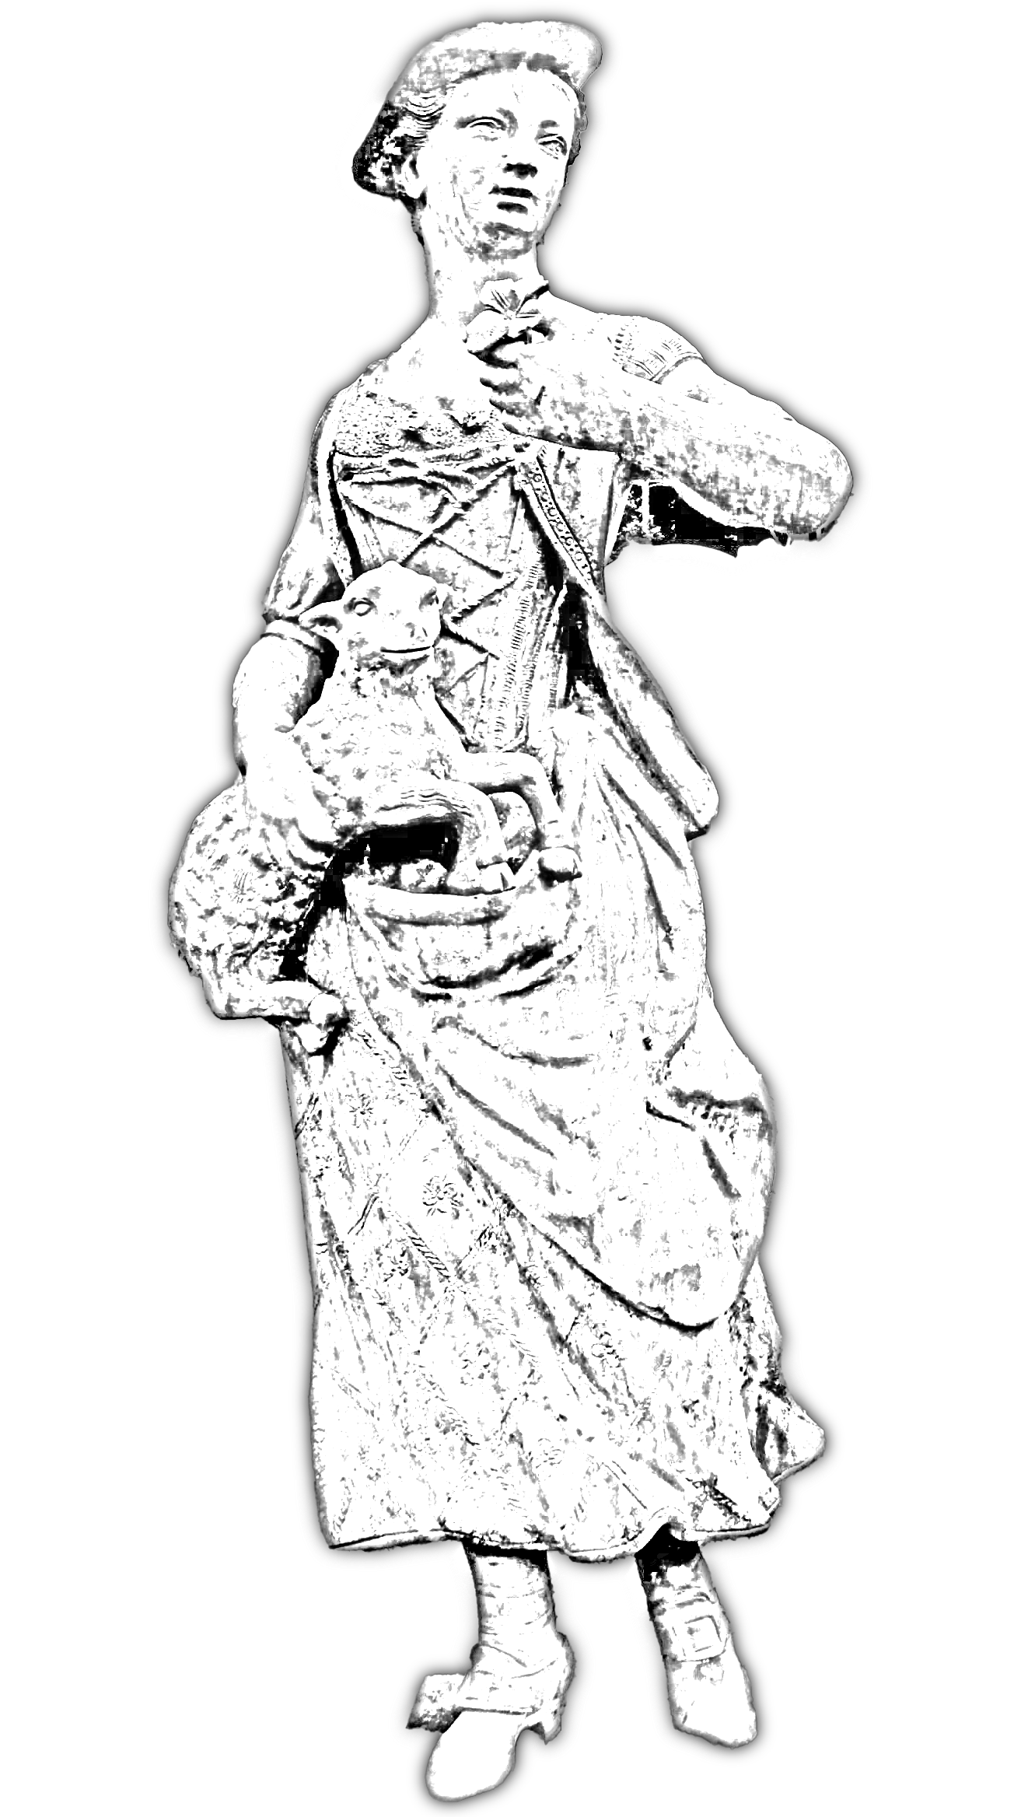
From Highlands to London: The Journey of the Flock
A Slow-TV pilgrimage of sheep, shepherds, and story — following 300 sheep from the Scottish Highlands to the heart of London, reconnecting Britain with its wool, its landscapes, and its future.

Why Now
2026 is the UN International Year of Rangelands and Pastoralists — a global spotlight on grazing lands and pastoralists. British wool production, usage and sheep numbers are in decline, landscapes are under threat, and audiences crave immersive, authentic stories. This is Britain’s moment to tell a powerful, positive story.

The Concept
Two Scottish shepherdesses guide a flock of 300 sheep along ancient drovers’ roads from the Highlands to central London. Slow-TV style coverage captures the landscape and the journey, while rotating stakeholders join along the way. Viewers can adopt a sheep, follow its journey, and contribute to related good causes. Streaming live 24/7 online with highlights on the BBC.

Key Themes & Impacts
• Biodiversity & Ecosystem Health: grazing reduces wildfire risk, improves soils, and supports diverse habitats.
• Cultural Heritage & Local Economy: revives traditional routes, wool trade and crafts.
• Education: school programmes link children directly with land, animals and science.
• Climate Action & Land Stewardship: shows pastoralists’ role in climate mitigation.
• Public Engagement: slow-TV invites calm, deep viewing.

Stakeholders to Engage
Worshipful Company of Woolmen, Campaign for Wool, British Wool, Fibershed UK, National Farmers’ Union (NFU), Scottish NFU, sheep breeders’ associations, Rare Breed societies, knitting and craft guilds, conservation NGOs (The Wildlife Trusts, RSPB, National Trust), universities and research bodies on grazing and ecology, local authorities, schools and community groups, and a key broadcaster such as the BBC.

Timeline (12-Month Preparation)
Months 1–3: Stakeholder outreach, steering group, route permissions, seed funding.
Months 4–6: Secure broadcaster, fundraising, production planning, educational partnerships.
Months 7–9: Test shoots, build web platform, finalize logistics.
Months 10–12: Publicity, final rehearsals, journey launch.

Budget & Funding
Budget items: production crew, live-streaming tech, travel and logistics for shepherds and animals, animal welfare and veterinary care, site permissions, post-production, marketing and audience engagement platform.
Funding sources: stakeholder contributions, sponsorship, government and environmental grants, philanthropic support.

Call to Action
Secure early commitments from wool industry stakeholders, researchers, and craftspeople.
Confirm BBC or equivalent broadcaster for highlights.
Raise seed funding to start route planning and permissions.
Identify key on-screen shepherds, researchers and artisans.

Highlands-to-London Sheep Drive: 60-Day Route & Timeline
A detailed 60-day slow-TV journey beginning on 26 September 2026 to align with the Worshipful Company of Woolmen’s ceremonial Thames bridge crossing in London.

Overview
Starting on 26 September 2026, two Scottish shepherdesses will guide ~300 sheep from the Scottish Highlands to Central London. The start coincides with the annual Woolmen’s London Bridge crossing, creating a symbolic city–Highlands link. At 15–20 km per day, the flock will travel approximately 900–1,100 km over 60 days, arriving in late November 2026.

Key Phases & Landscapes
• Highlands (Days 1–5): Cairngorms and Spey Valley ceremonial launch and prologue.
• Pentland Hills & Scottish Borders (Days 6–14): Cross Borders Drove Road and Cauldstane Slap.
• Cheviot Hills / Northumberland NP (Days 15–24): Historic Dere Street corridor.
• North York Moors NP (Days 25–36): Hambleton Drove Road, traditional droving landscapes.
• Vale of York to Chilterns (Days 37–48): Lowland farms and soil-water engagement.
• Chilterns National Landscape (Days 49–56): Icknield Way chalk ridge.
• Greater London Green Corridors (Days 57–60): Lee Valley or Colne Valley Regional Park into London.

Indicative Timeline
• 26 September 2026: Start in the Scottish Highlands while the Woolmen cross London Bridge.
• Mid-October: Enter England through the Cheviots.
• Late October: Reach North York Moors.
• Mid-November: Enter the Chilterns.
• Late November: Arrive in Central London for final celebration.

Distance and Daily Pace
• Average distance: 15–20 km per day.
• Total distance: approximately 900–1,100 km.
• Includes planned rest and school/craft engagement days.

Key Features
• Live-streamed 24/7 with BBC daily highlight broadcasts.
• Audience ‘adopt a sheep’ program for interactive engagement.
• Rotating participation of stakeholders: Woolmen, Campaign for Wool, British Wool, Fibershed UK, NFU/SFU, rare-breed societies, conservation NGOs, craft guilds.
• Mobile wool workshops, school visits, and grazing science demonstrations.

Permits and Compliance
• Sheep movement reporting and transporter authorisations as per APHA/DEFRA guidance.
• Rights-of-way and local authority permissions for the entire route.
• Filming permissions from park authorities and councils.
• Animal welfare and contingency planning for disease control.

Next Steps
1. GIS-based detailed mapping of the ~900–1,100 km route.
2. Secure agreements with key stakeholders including the Worshipful Company of Woolmen and BBC.
3. Finalize permissions with national parks, regional park authorities, and local councils.
4. Develop funding and sponsorship plan for a 60-day live production.
5. Plan school and craft engagement along each major phase.

