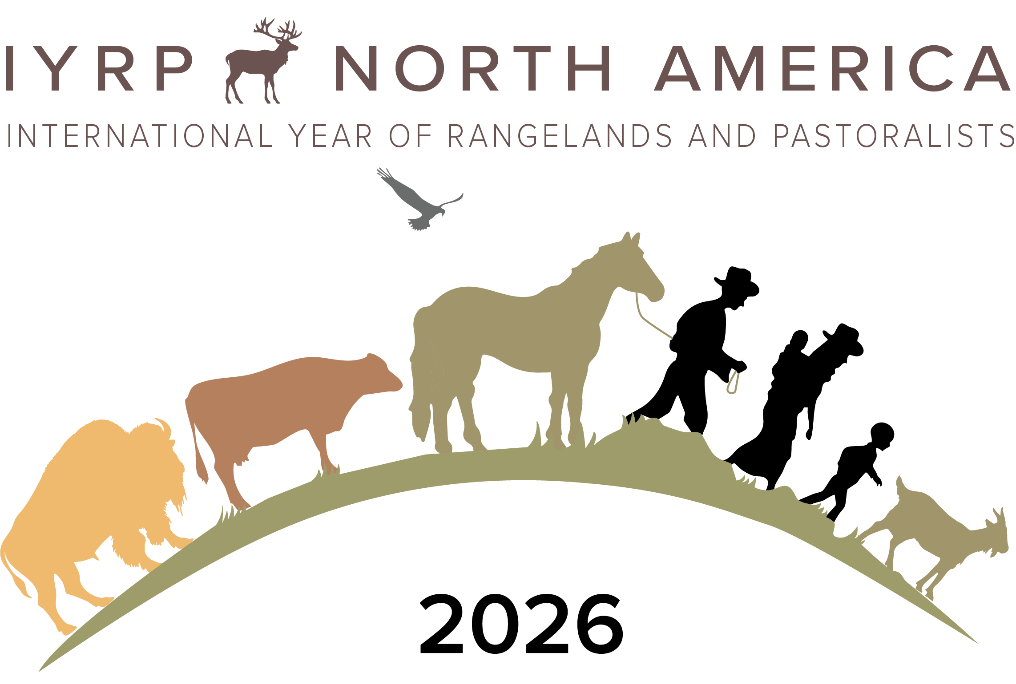
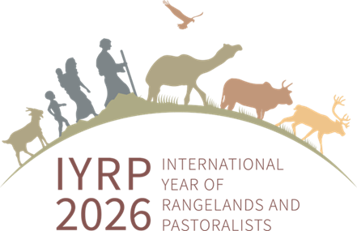
Documentary Film Project
“American Rangelands: A Revival”

You Can Be a Part of This Effort!

In honour of the International Year of Rangelands and Pastoralists (IYRP2026), members of the North America IYRP Support Group and the Rangelands Partnership have initiated an effort to produce a feature-length documentary film about North American rangelands. This documentary, to be premiered in 2026, focuses on their importance for meeting 21st Century environmental, cultural, and economic challenges; and specifically, for addressing climate variability with new technologies and strategies (https://www.iyrp.info/north-america/film-projects/documentary-film). Storytelling is the vehicle used for highlighting the historic and intrinsic values of these lands within the context of indigenous knowledge and current science. The long-term goal is to change public perceptions regarding the value of these lands and the need to conserve them. By presenting real-life stories about the people whose livelihoods depend on these lands, viewers will learn about collaborative conservation efforts and the many ecosystem services provided by rangelands to people in all walks of life. These include clean water, wildlife habitat, wildfire control, carbon storage, renewable energy, recreation and food and fibre products.

With input from the film’s Advisory Board and sponsors, overall themes were determined:
- Rangelands and pastoralists defined
- Historical overview of rangelands including Native American perspectives
- Climate solutions
- New technologies & strategies, i.e. virtual fencing, drones/remote sensing, grazing strategies
- Ecosystem services: clean water, carbon sequestration, wildlife habitat, recreation, wildfire control, renewable energy.
- Connecting people to rangelands; keeping working lands “working”; how we can help protect our rangelands
  - Land cultivation/fragmentation issues
  - Generational transfer, Conservation easements
  - Call for action

Funding for the film is an ongoing grassroots effort involving the Western Association of Agricultural Experiment Station Deans & Directors (WAAESD), the Rangelands Partnership, and the film’s coordinating team. To date, six land-grant universities have donated to the effort and three competitive grants were awarded (https://www.iyrp.info/donations-received). All donors will be included in the film’s credits.

Landmark Stories, an award-winning filmmaking team based at the University of Arizona, is producing the film (https://landmarkstories.arizona.edu/). This team has considerable experience in documentary storytelling on natural resources themes and also strong ties with environmental film distributors.

For more information or to contribute, please contact the producers: Barbara Hutchinson (barbarah@cals.arizona.edu) or Flavie Audoin (faudoin@arizona.edu)

