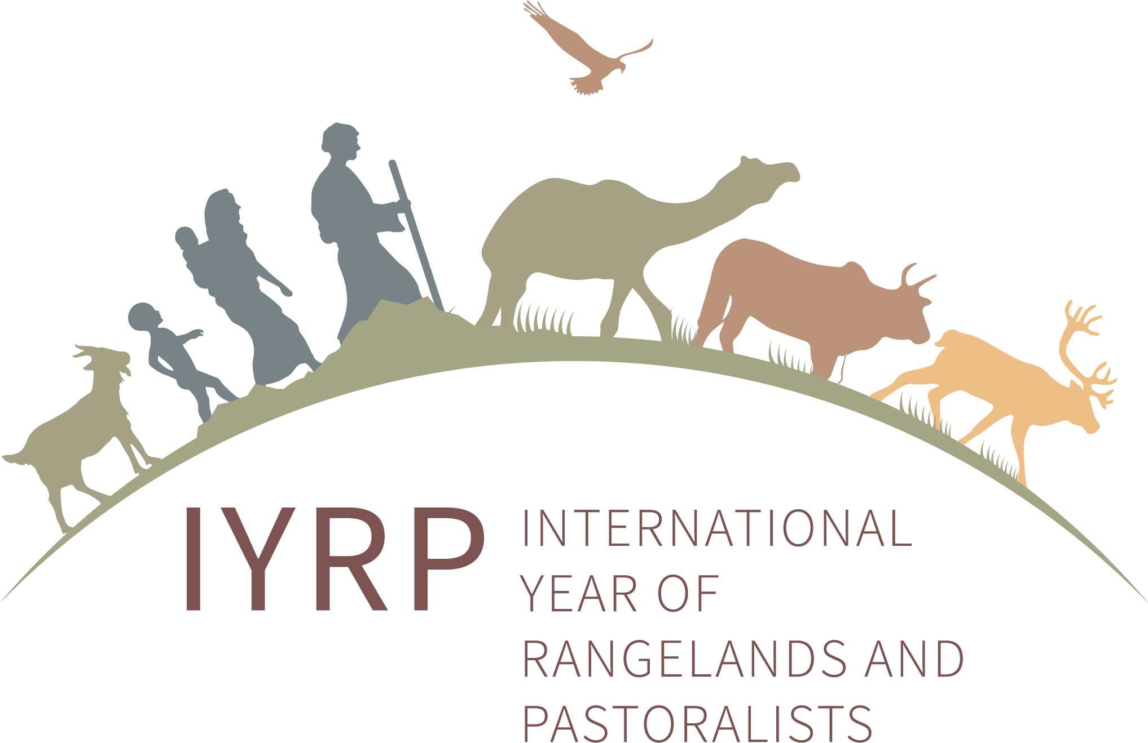

**IYRP Pastoralist Youth Working Group**

**Draft concept note**

**Headline message**

The greatest opportunities for change in pastoralist societies lie with the youth – they are often better educated and more in touch with emerging technologies and trends – but youth are often marginalised within pastoralist societies and increasingly seek to leave the pastoral system in search of better lives. The sustainable future of pastoralism depends on empowering pastoralist youth, addressing their needs, and enabling their entry into and innovation within the pastoral system.

**Introduction**

The International Year of Rangelands and Pastoralists (IYRP) recognises pastoralist youth in its proposed global framework and as one of the central themes for the year 2026. Pastoralist youth – of all genders – represent the future of pastoralism, inheriting and learning traditions and sustainable practices that have shaped pastoralism for generations. They also play a crucial role in accessing information and technologies, acting as a source of innovation and contributing to the sustainable development of these livelihoods. However, they require support and rights within and outside their communities to realise their full potential.

Several working groups have been formed under the IYRP initiative for knowledge exchange, advocacy and raising awareness on pastoralism and rangelands. Among the working groups, the Pastoralist Youth Working Group emerges as a platform dedicated to amplifying the voices and perspectives of Pastoralist Youth. Through collaborative efforts and grassroots engagement, the working group aims to elevate the contributions of Pastoralist Youth on the global stage pre- and post the IYRP in 2026.

**Objectives**

* Empower pastoralist youth to become agents of change in pastoralist communities – increase pastoralist youth and pastoralist youth organisation participation.
* Promote the active engagement of pastoralist youth in decision-making processes related to pastoralism and rangeland management.
* Advocate for policies that recognise and support the unique contributions of pastoralist youth to sustainable pastoral livelihoods and rangeland management.
* Foster knowledge exchange and collaboration among pastoralist youth at local, national and international levels.

**Thematic issues**

1. Representation and engagement of pastoralist youth, including their active participation in the IYRP initiative, global forums, influential documents, and reports related to pastoralism and rangelands.
2. Youth migration away from pastoralism and elevation of the perceived status of pastoralism among the youth to encourage retention and pride in pastoral lifestyles.
3. Education for pastoralist youth by enhancing access to both formal education at higher levels and specialised training, such as shepherding schools and relevant academic courses, to build capacity.
4. Preserving cultural heritage through valuing knowledge and intergenerational transfer of traditional pastoral herding knowledge.
5. Collecting relevant and context-specific data on youth in pastoral households to ensure evidence-based interventions that address actual needs of pastoralist youth.
6. Challenges related to land access and high entry barriers for youth, particularly those without inheritance or the means to acquire land.
7. Economic opportunities for youth in sectors complementary to pastoralism, such as food processing and other agribusiness ventures, to enhance the viability of pastoral economies.
8. Identifying main hindrances that prevent pastoralist youth from developing sustainable livelihoods within pastoralism.
9. Improving working/labour conditions that attract unemployed youth to pastoralism and strengthening weak labour rights that discourage entrance and participation in pastoralism.
10. Succession planning and governance transition from the elder pastoralists to the younger generation, ensuring continuity and the infusion of new ideas in pastoralism.

NB: We might not be able to address all these thematic issues comprehensively. Nevertheless, we will strive to prioritise the most pressing concerns, seek collaborative solutions, and make meaningful progress wherever possible.

**Action items**

**Advocacy priorities - Short-term (Pre IYRP 2026)**

* Ensure active pastoralist youth representation and engagement in the IYRP initiative and related global forums.
* Establish a pastoralist youth network for pastoralist youth to connect, collaborate and exchange knowledge.
* Advocate for policies that encourage youth involvement in livestock development, sustainable rangeland management, and related innovative technologies.
* Promote educational access and integration for accessible, diverse educational pathways for pastoralist youth, including vocational and specialised learning, e.g. shepherding schools.

**Strategic priorities - Long-term (Pre and Post IYRP 2026)**

* Support youth participation in the animal value chain, promoting their role in market development, being a link, for example, to enterprises for processing milk, meat and other livestock products or establishing fattening kraals
* Provide training on fodder flow plans, introduce youth to climate-smart forage production through hydroponics and cover crops and help them set up profitable businesses to sell the fodder to pastoralists within their communities.
* Propose inclusive land access policies and actionable strategies for equitable land distribution and use, ensuring youth have the opportunity to contribute to pastoralist economies.
* Lobby for governmental support and investment in youth-focused livestock and rangeland development programmes

**Deliverables**

* Develop key messages for the thematic issues concerning pastoralist youth, forming the foundation of our advocacy and communication strategy, ensuring a consistent and focused narrative.
* Using social media to strategically disseminate information, engage with youth and highlight success stories of pastoralist youth.
* A short communiqué with key messages (e.g. two-page briefing note) on pastoralist youth
* Organise an online event/webinar for pastoralist youth by pastoralist youth – Theme/topic TBC to discuss pivotal issues, exchange experiences and strategies and collaborate on collective objectives.
* A needs assessment report on specific challenges and opportunities of pastoralist youth, guiding future actions and interventions.