Update on activities of the IYRP International Support Group
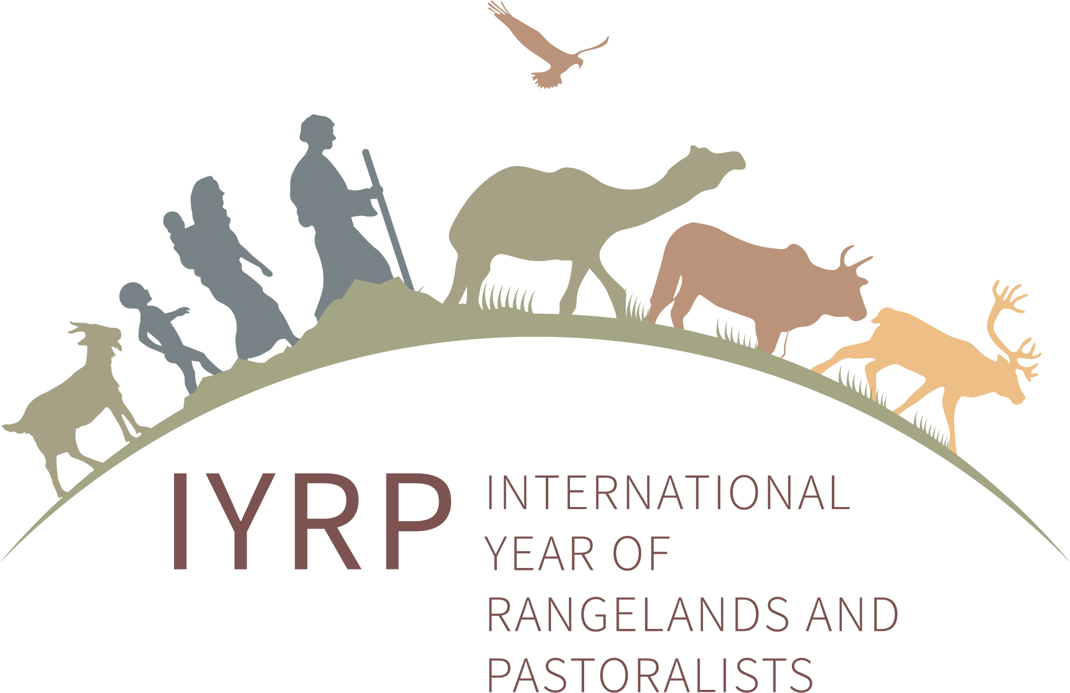
November 2023

The UN General Assembly has adopted the resolution and declared 2026 the International Year of Rangelands and Pastoralists (IYRP). The IYRP reflects the importance of rangelands in creating a sustainable planet and supporting economic growth and resilient livelihoods for pastoralist communities around the world. Although the Food and Agriculture Organization (FAO) will be facilitating the implementation of the IYRP in 2026, already now the IYRP International Support Group is actively involved in preparing for the International Year.
The IYRP 2026 seeks:
- To increase worldwide understanding of the value of rangelands and pastoralism for food security, economy, environment and cultural heritage
- To fill knowledge gaps about rangelands and pastoralists through participatory research and strategic communication
- To promote informed, science-based policy and legislation for current and future generations
- To advocate for strengthening the capacity of the pastoralism sector and for increasing responsible investment in sustainable land-use practices, equitable access to markets, and the health and wellbeing of people and animals in the rangelands as a climate solution.

Structure of the IYRP 2026 coalition
The IYRP 2026 coalition consists of an International Support Group (ISG) with members from around the world, collaborating in Regional IYRP Support Groups (RISGs) and thematic Working Groups, coordinated by a multistakeholder Global Coordinating Group (GCG). Information is shared primarily through the IYRP website and listserv. To join this listserv, contact iyrp@iyrp.info

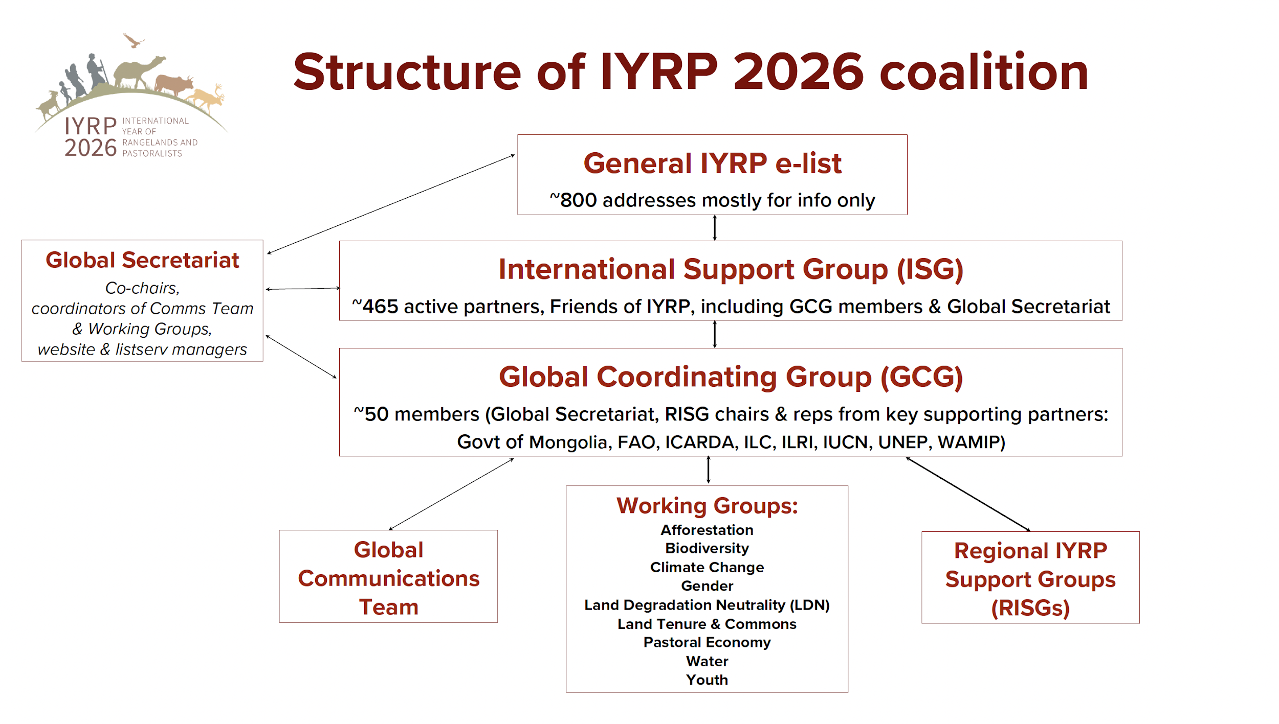

Feature:

FAO COFO Working Group and IYRP co-host 1st Summer School on Drylands


The FAO Committee on Forestry (COFO) Working Group on Dryland Forests and Agrosilvopastoral Systems (WG) and the Global Secretariat of the IYRP 2026 hosted the inaugural Drylands Summer School on 12–15 September in Amman, Jordan. The 4-day training course attracted 21 participants from dryland regions worldwide. Its purpose was to arm them with knowledge and skills, improving their ability to enhance dryland resilience with the intention to nurture a cohort of dryland advocates in anticipation of IYRP 2026.
The Summer School aimed to:
- Train practitioners in transformative approaches to fortify dryland system resilience
- Convene planners and practitioners to assess the impact of their actions in drylands, guiding them toward sustainability
- Equip participants with skills to devise context-specific solutions for agrosilvopastoral systems, defining cross-cutting indicators for progress.
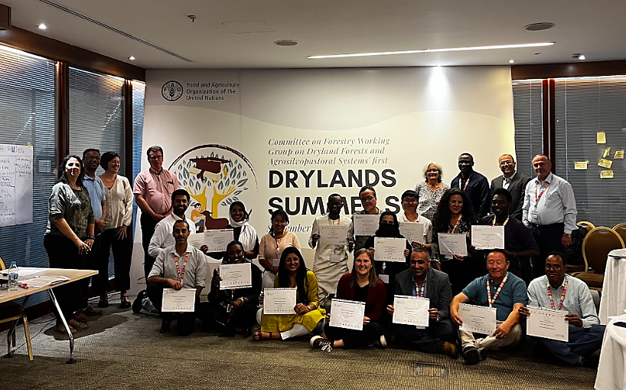

The syllabus covered diverse topics such as dryland challenges, South–South knowledge sharing, biodiversity conservation case studies and gender-responsive approaches. Additionally, the programme featured a one-day field visit to the Royal Botanic Gardens in Amman and the participants conducted a stakeholder analysis of the Community-Based Rangeland Rehabilitation (CBRR) project, focusing on sustainable rangeland management through community knowledge revival and science-based interventions. The attendees were awarded with course completion certificates. The second edition of the Drylands Summer School is set to be in Kenya in 2024 with the focus on ecological monitoring.

Update on the Thematic Working Groups of the IYRP
Jonathan Davies (Working Groups coordinator)

Through the thematic Working Groups (WGs), the IYRP seeks to achieve greater awareness in science & society about how rangelands & pastoralists contribute to food security, economy, environment & cultural heritage. The WGs are working towards informing resolutions taken by the UN and other international entities and changes in national, regional & global policies in support of rangelands & pastoralists.

Working Group: Afforestation in Rangelands
- Coordinators: David Briske (Texas A&M University, USA) & Susi Vetter (Rhodes University, South Africa)
- A state-of-the-science evidence-based paper written by this WG “Rangeland afforestation is not a natural climate solution” has been accepted for publication.
- Key message of the paper: Rangelands are valuable ecosystems, and afforestation efforts driven by a climate change mitigation agenda present a serious risk to them.

Working Group: Pastoralism & Gender
- Coordinator: Nitya Ghotge (ANTHRA, India)
This WG aims to:
- Highlight the advantages of bringing a gender lens to pastoralist policy & development
- Disseminate key information around gender & pastoralism and generate discussions on this topic
- Identify gaps in research on gender & pastoralism
- Support the other IYRP WGs in their efforts to incorporate a gender lens into their work.

Working Group: Pastoralism & Water
- Facilitators: Adrian Cullis & Kerstin Danert
- Focus on water governance as well as water-related ecosystem services and rangeland land & water management.

Working Group: Rangelands & Land Degradation Neutrality (LDN)
- Coordinators: Bora Masumbuko (IUCN) & Mounir Louhaichi (ICARDA)
- Focus on the UN Convention to Combat Desertification (UNCCD) with two critical issues for raising awareness within the UNCCD process:
  - The value of rangelands and pastoralism
  - Conversion of rangelands.
- A Science-to-Policy review “Global action for sustainable rangelands and pastoralism to achieve Land Degradation Neutrality” has been completed.
- Will undertake research and analysis, conduct case studies and disseminate knowledge products in the form of policy briefs, animated videos, webinars etc.

Working Group: Rangelands & Biodiversity
- Coordinators: Rashmi Singh with support from Matthew Luizza
This WG focused on biodiversity and ecosystem services seeks to convey the following key messages:
- Rangelands hold exceptional biodiversity values, including being the habitats of numerous endangered species and representing one third of all global biodiversity hotspots.
- Rangeland biodiversity has been shaped and has co-evolved with pastoralism for centuries, and effective restoration and conservation of the rangelands requires pastoralism to continue to use sustainable management practices.
- Flexible pastoral mobility should be facilitated to ensure rangeland biodiversity, which is threatened when sustainable pastoral movements are undermined through alienation of land, loss of mobility and fragmentation of landscapes.
- Policies and investments that uphold pastoral rights and enable pastoral management systems will play a significant role in restoring and sustainably managing rangeland biodiversity.

Working Group: Economics of Pastoralism (under development)
- Coordinator Serena Ferrari (CIRAD, France)
- Initial foci will be on valuing pastoralism (contribution to GDP, imports and exports of pastoral products, etc.); competition at national level between pastoral products and industrial-sourced products; constraints that pastoralists face in marketing their products; sustainable production and consumption.

Working Group: Pastoralist Youth (under development)
- Coordinator Caroline Ruto (UN & Kansas State University)
- Draft concept note is drafted and will soon be posted on the IYRP website.

Working Group: Rangeland Tenure & Commons (under development)
- Coordinator: Natasha Maru (International Land Coalition)
- Currently developing a briefing note and outlining main outputs from the group.

Working Group: Climate Change (under development)
- Topics to be covered include: carbon sequestration in rangelands and carbon footprint of livestock; whether climate change projects benefit pastoralists; and impacts of climate change on pastoralists & rangelands and future adaptation.
New members are welcome to join the WGs. Concept notes for the WGs are on the IYRP website (https://iyrp.info/resources/front).

Selected highlights from the 11 IYRP regions
Multistakeholder Regional IYRP Support Groups (RISGs) were formed in 11 regions around the world to generate partnerships. They seek to expand the network of supporting individuals, organisations and governments and to work with the ISG in planning and implementing IYRP activities in these regions and in countries within them. Several of the RISGs are co-chaired by representatives from pastoralist organisations.
Contact details for the RISG coordinators can be found here: www.iyrp.info/resources/front
Short reports on the work of the RISGs can be found in the IYRP updates: www.iyrp.info/resources/news

Australasia
- The RISG is restructuring how it will undertake activities leading up to IYRP 2026. Subregional groups are being formed on a state basis in Australia (Western Australia, South Australia, New South Wales) and a separate group in New Zealand. Pastoralists will chair these groups, and the chairs will form the National Committee, along with other important stakeholders.
- Dana Kelly facilitated a short strategic planning exercise with the Western Australia IYRP Group. Brainstorming of ideas suggested local horse-racing meetings, rangelands revitalisation projects, and cultural activities such as music concerts in the rangelands.
Other activities currently underway include:
- An Australia-wide Indigenous Corporation has agreed to host the Traditional Knowledge Forum (planned for 2025).
- Develop a friendship group with Kenya, with the aim of exchanging knowledge.
- Develop an Australian/New Zealand logo.
- Develop simple templates for flyers, posters and a newsletter for use by subregional groups.
- Develop business bases to seek funding for administration and specific projects.
- Discuss a potential book of case studies from different perspectives, celebrating positive stories from the rangelands.
- Produce a series of flyers to encourage involvement of stakeholder groups including pastoralists.

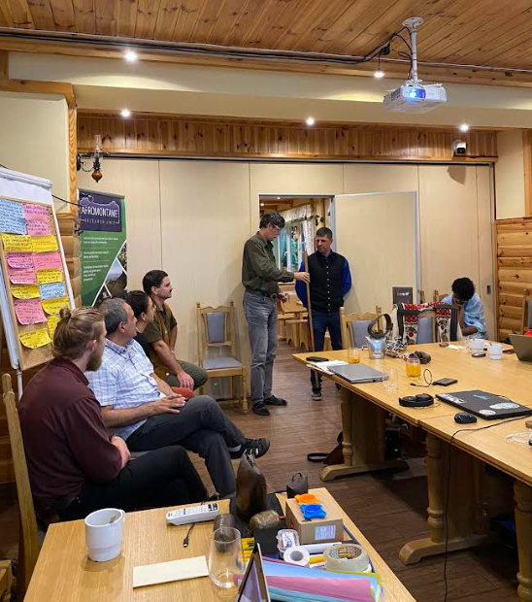
Central Asia & Mongolia (CAM)
- On 10–20 Sept, Hasrat Arjjumend, CAM RISG co-chair, hosted a 4-day training course for 300 participants on “Mountain Ecosystems & Resource Management”. It included topics such as Mountain Transhumance, Pastoralism and Rangeland Governance. The CAM RISG members Rural Development Fund and JASIL conducted the lectures and training.
- Several Mongolian herders’ communities registered on the Global ICCA Registry in Aug–Sept. This process will support pastoralist communities as custodians of Territories of Life.

East Asia
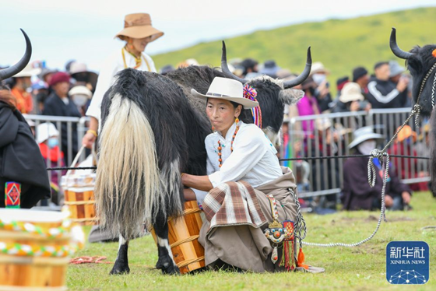
- On 24 August, Long Ruijun, co-chair of the East Asia RISG, delivered a keynote speech at the Yak Pastoralism Development Conference in Sichuan, China, in which he emphasised the relevant activities and significance of the IYRP to more than 500 representatives from several provinces in China.
- In the evening, Prof. Long attended the opening ceremony of the 12th Yak Culture Festival (YCF) in Hongyuan County, Aba Prefecture. The YCF lasted for 3 days; activities included a series of competitions such as herdsman performances, herdsman weight-bearing competitions, yak running competitions, the best bull selection, the best yak dairy cow selection, yak training competitions, and children riding calves.

Eastern and South Africa
- Pastoral youth from Uganda, Ethiopia, Somalia, Tanzania and South Sudan attended the African Youth Pastoralist Landscape Initiative (AYPLI) event on 14 Nov. It brought them up to speed on the IYRP 2026 roadmap and shared the aspirations of the IYRP Working Group on Pastoralist Youth. The meeting aimed to increase awareness about the contributions of pastoralism to food safety and culture and to advocate for favourable policies for pastoralists.
- The Karamoja Cultural Event held on 4–9 Sept in Karamoja, Uganda, attracted cross-border support and participation with over 1000 celebrants. This is a community-initiated event, supplemented by government and civil society and donor support.

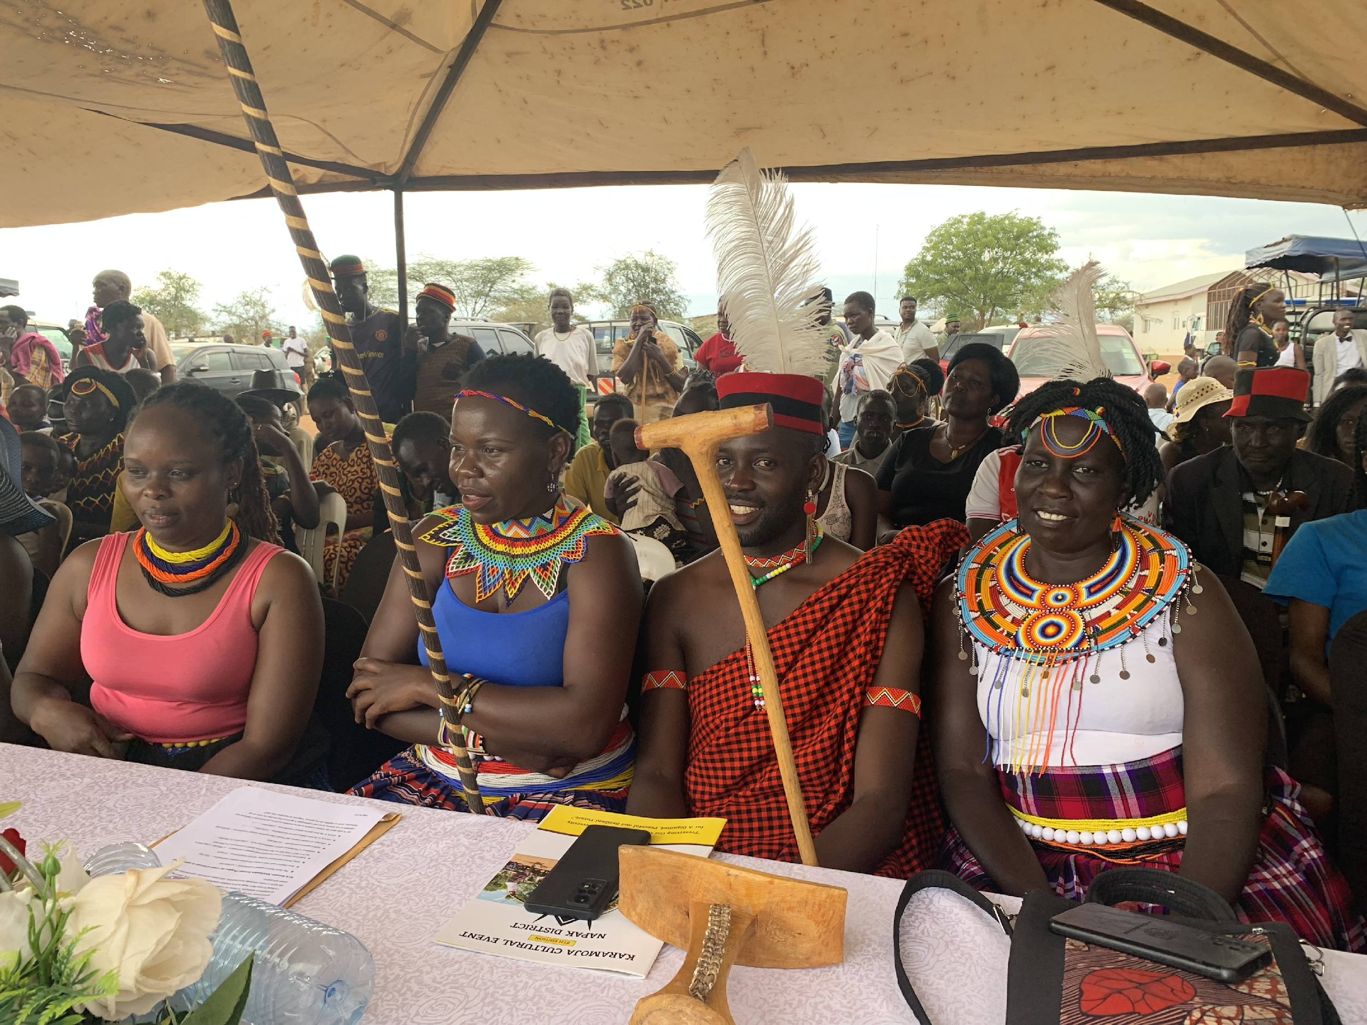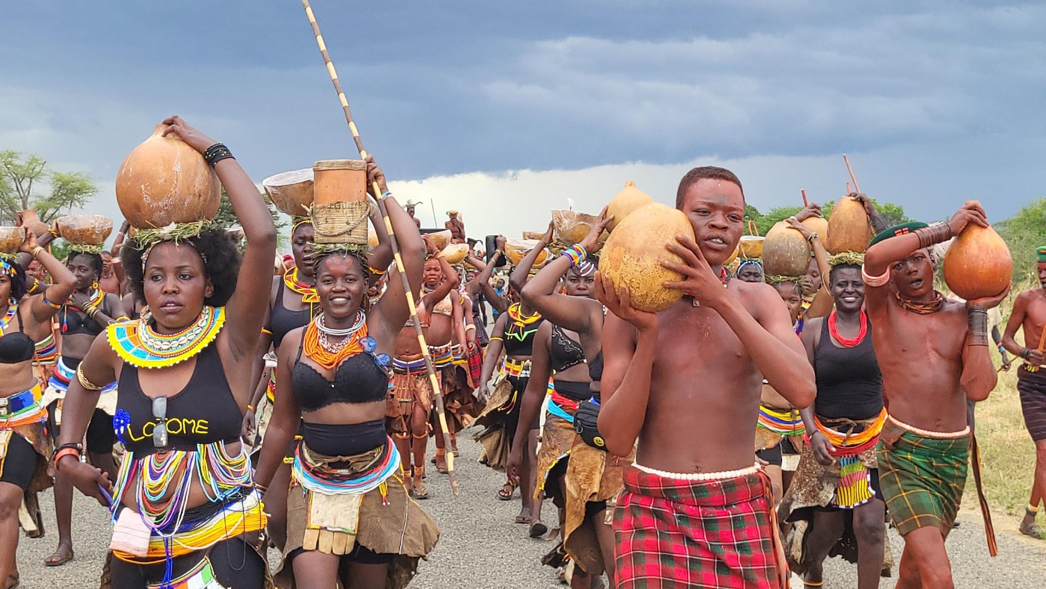
- South African IYRP members are implementing a nation-wide long-term rangeland monitoring project funded by their government. The project aims to assess how the health of rangelands at 1500 locations changed over time and what the implications are for pastoralists and the provision of other ecosystem services. It also aims to develop a detailed rangeland map of the country to assist in policy and management decisions.

Europe
- At the Festival of Transhumance of Sierra de Estrela, Portugal, in Sept, the IYRP was launched and actions were planned for Portugal and common IYRP actions with other countries, through common EU-financed projects.
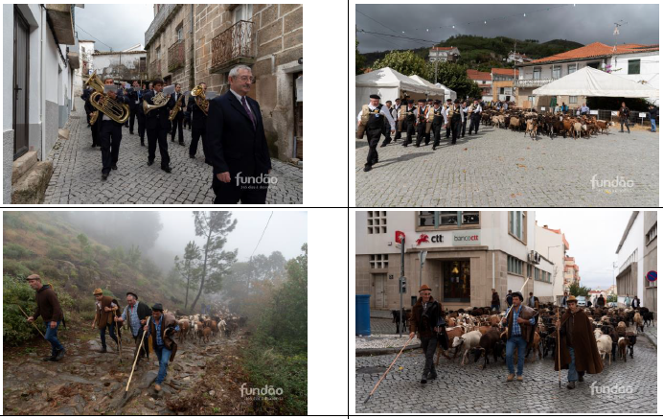
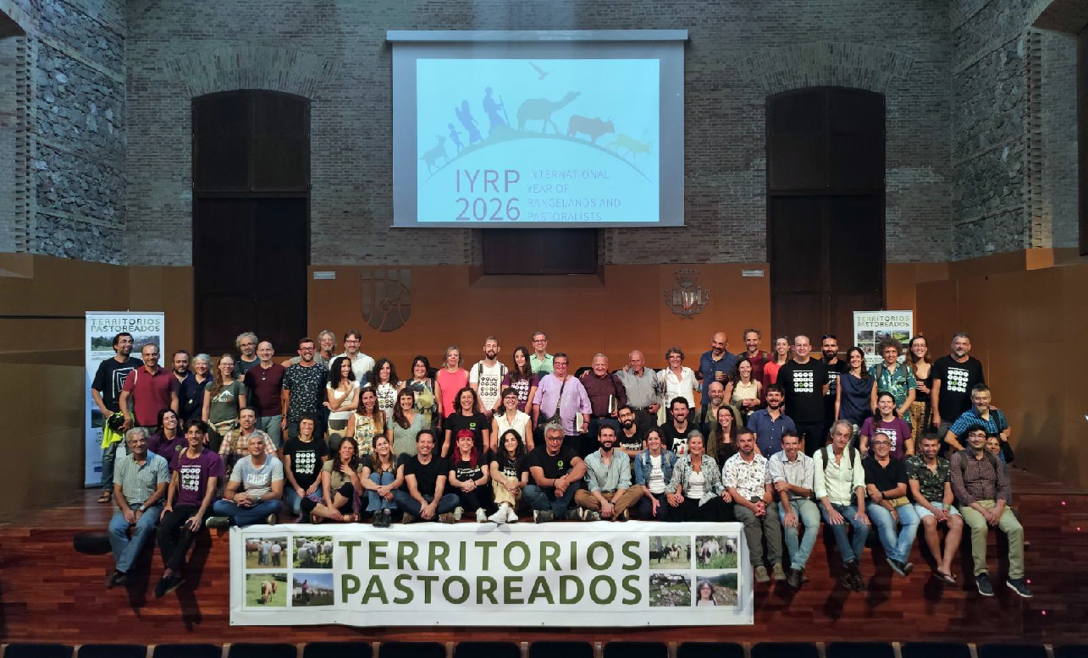
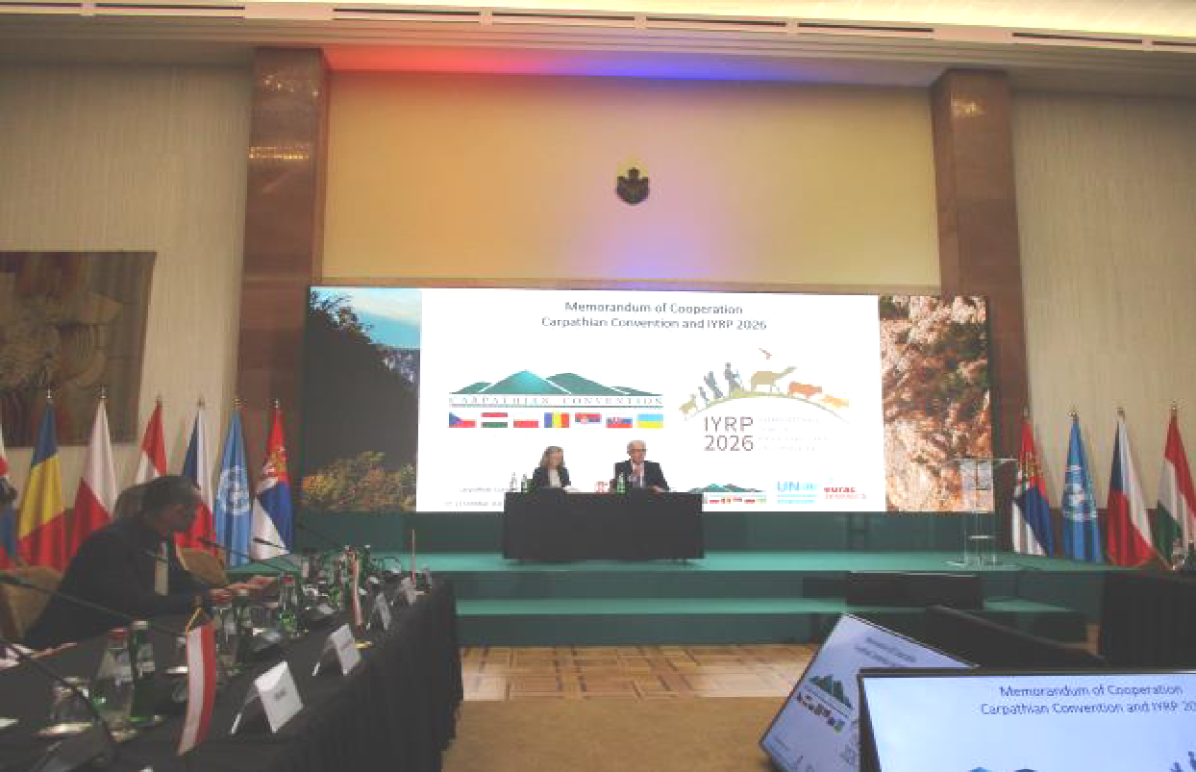
- On 27–30 Sept in Valencia, Spain, the Territorios Pastoreados 6 meeting of the Spanish Platform of Extensive Livestock Keeping and Pastoralism (SPELKP) highlighted the difference between pastoralism and other livestock-keeping systems. The event was attended by about 200 people including pastoralists from all over Spain, Women Pastoralists of Spain (Ganaderas en Red) and experts in different areas of pastoralism. Two co-chairs of the Europe RISG presented the IYRP. An SPELKP working group on the IYRP was officially declared during the meeting.
- On 11–14 Oct, a Europe RISG co-chair joined the Carpathian Convention COP7 meeting in Belgrade, Serbia, and signed a Memorandum of Cooperation between IYRP and the Carpathian Coalition, which has 7 member countries.

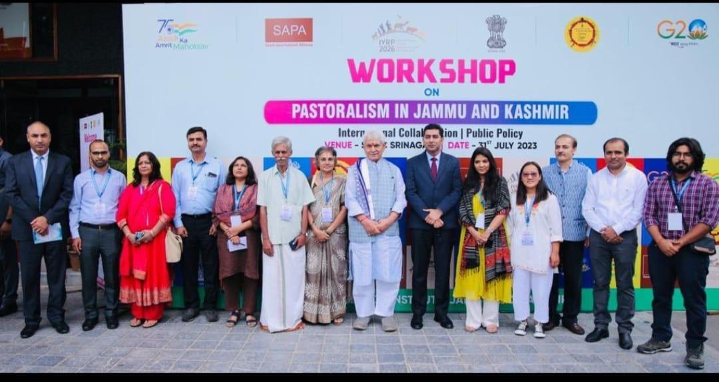
South Asia
- On 31 July–1 Aug, members of the South Asia RISG were involved in a 2-day workshop in Srinagar, Kashmir, on “Pastoralism in Jammu and Kashmir: Issues, Challenges, and the Way Forward”. More than 200 people attended the workshop, including government officials, faculty members, students, pastoralists across the Union Territory of Jammu and Kashmir, various NGOs and volunteers. South Asia RISG co-chair P. Vivekananda introduced the IYRP. Addresses on different aspects of pastoralism in Jammu and Kashmir were given. In the inaugural address, Hon’ble Lt. Governor, Shri Manoj Sinha ji mentioned that mobile livestock play an important role in the business and livelihood of communities and is deeply connected with heritage, culture, traditional knowledge and co-existence with nature. He sees pastoralists as forest protectors and climate warriors who play a significant role in maintaining biodiversity, mitigating climate change and contributing to growth and food security.
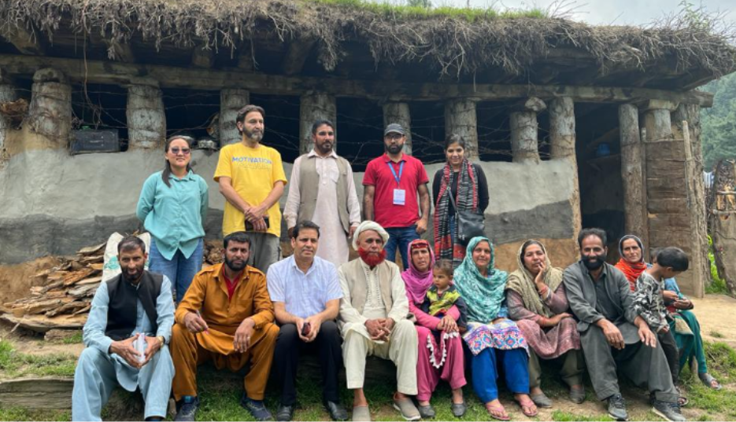
- On 1 Aug, the team made a field visit to interact with Bakkarwal and Gujjar community members at Shirmal, sub-alpine pastures at Goripathri, Heerpora and Dubjan areas of Shopian District. It also interacted with officials of mobile veterinary clinics of the Sheep Husbandry Department of Jammu and Kashmir.
West and Central Africa (WCA)
- The WCA RISG completed their Action Plan for IYRP 2026, which can be found here.
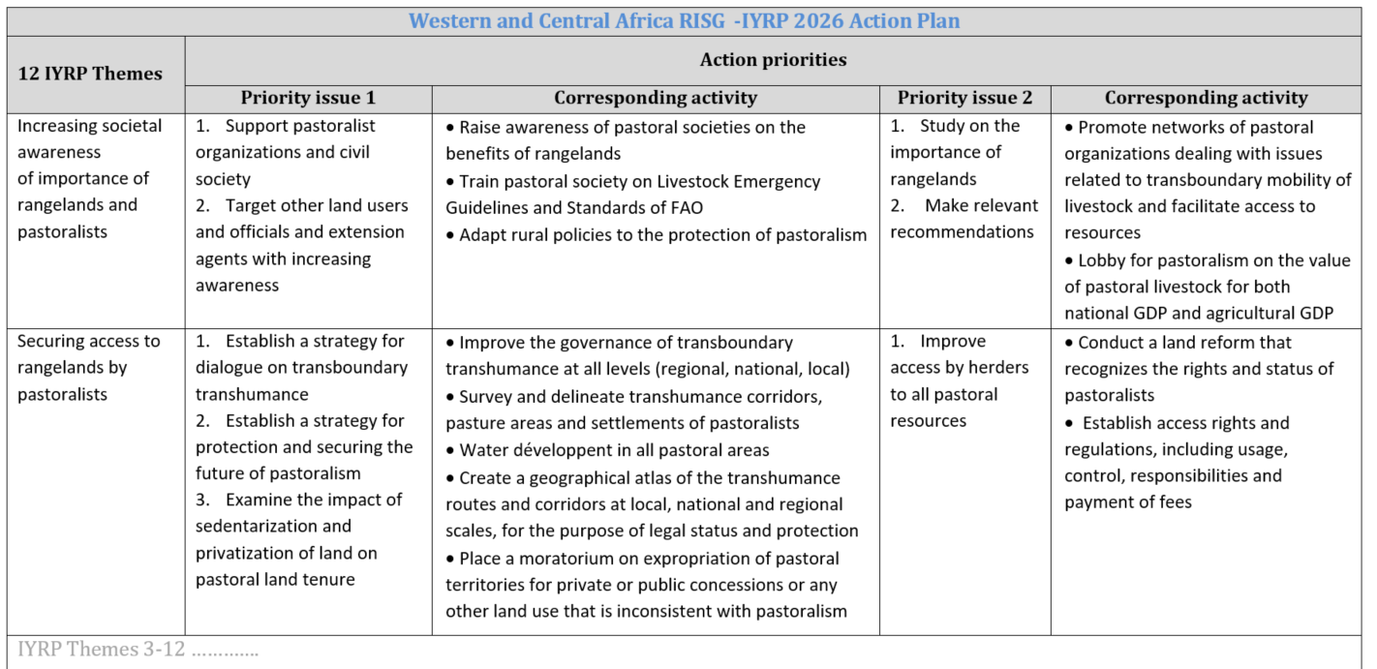
- The WCA RISG will host a scientific conference “(Agro)pastoralism in Africa” in Dakar, Senegal, in November 2024, which will gather participants especially from the WCA region, with keynote speakers from other regions of the world.

North America RISG
- During the XII Mexico International Grassland Management Congress in Durango, Mexico, on 27–30 Sept 2023, a workshop was held to develop the action plan for Mexico for IYRP 2026. The theme of the congress was around the ecosystem services of grasslands and sustainable livestock farming. The event was attended by more than 600 people, including a large number of Durango ranchers. The workshop’s objective was to agree on actions to create awareness on the importance of grasslands among the Mexican population. These actions were identified jointly by technicians, researchers and producers.
- The Society for Range Management (SRM) in the USA has approved an International Affairs Committee proposal to provide hundreds of complimentary international online registrations for IYRP supporters who want to attend the 2024 SRM gathering at Sparks (Reno), Nevada, in February 2024. The SRM has also indicated that it will provide US $5,000 in support for an IYRP documentary film for the USA.

South America RISG
- From 11 to 14 July 2023, Cecilia Turin, co-chair of the RISG in South America, participated in the "International Congress on High Andean Llama and Alpaca Livestock in the Region of Arica and Parinacota" in Arica, Chile. The congress brought together researchers, civil society, government and FAO representatives to discuss the current situation on South American camelids in the Andean region. Cecilia made a presentation on “Camelid pastoral systems in southern Andean Peru: changes, adaptations and future prospects”, in which she introduced the IYRP 2026 and highlighted the importance of pastoralists, including those who keep camelids.
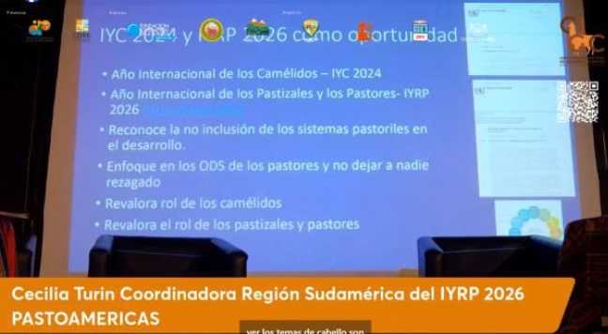
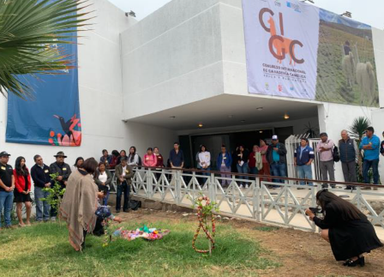

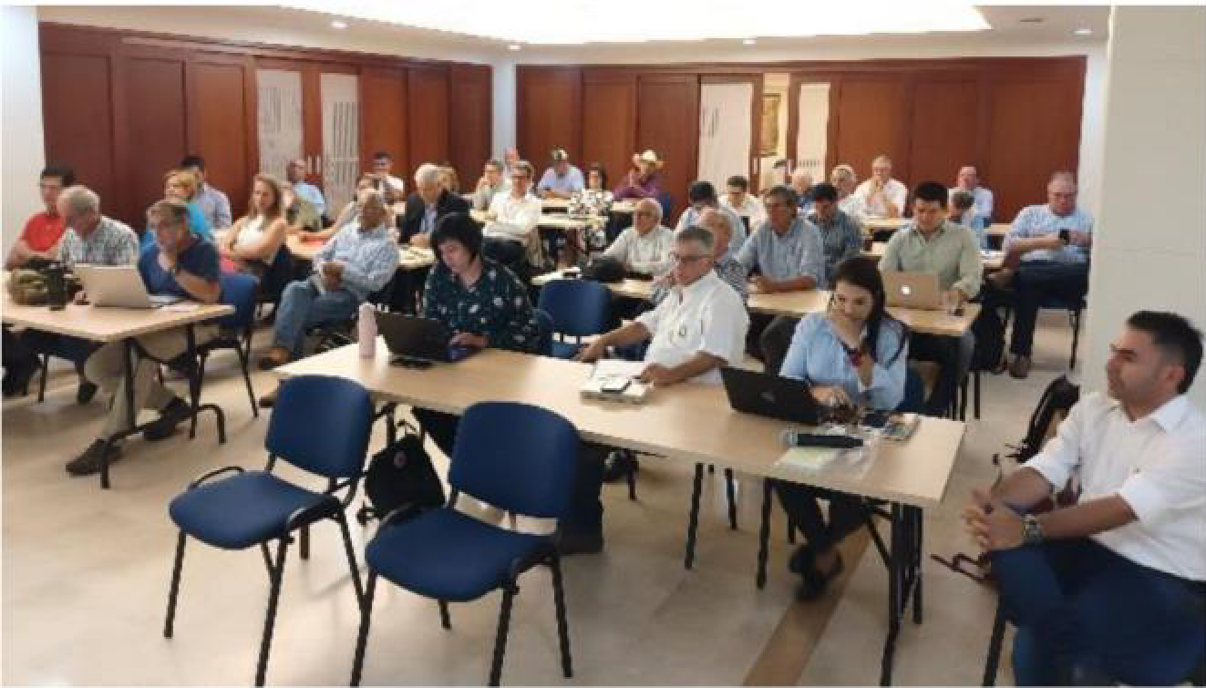
- Pablo Frere, likewise a co-chair of this RISG, took part in the Global Agenda for Sustainable Livestock (GASL) Regional Meeting for Latin America and the Caribbean in preparation for the 13th Multi-stakeholder Partnerships Meeting of GASL. This preparatory meeting took place on 20–21 Sept in Cali, Colombia. Silvopastoral systems and the IYRP 2026 were discussed.
- South American RISG members took part in the 19th International Union of Anthropological and Ethnological Sciences (IUAES) & World Anthropological Union (WAU) World Anthropology Congress on 14–20 in Delhi, India. The panel “Pastoral Marginalities and Uncertainties in Latin America Today” was organised by Greta Semplici of the PASTRES (Pastoralism, Uncertainty & Resilience) project and Pablo Manzano of the Basque Centre for Climate Change (also co-chair of the RISG). The panel sessions covered contributions on pastoralism from six Latin American countries (Argentina, Chile, Colombia, Mexico, Panama and Peru). Cecilia Turin from Peru presented “Camelid pastoralist systems in southern Andean Peru: changes, adaptations and future perspectives”. Clara Rua from Colombia presented “Wayuu pastoralism”, and Greta Semplici and Pablo Manzano presented “Diversity and sustainability of Latin American pastoralism: an overview of seven case studies”.

IYRP involvement in global activities
UNCCD workshop on rangelands:
- The Global Mechanism of the UNCCD held a scoping workshop on rangelands on 23–25 Oct in Rome, Italy. The event brought together key organisations working on rangelands and pastoralism to scope the opportunities available to enhance synergies on this topic. The workshop was the first step towards a common ambitious roadmap for IYRP 2026.
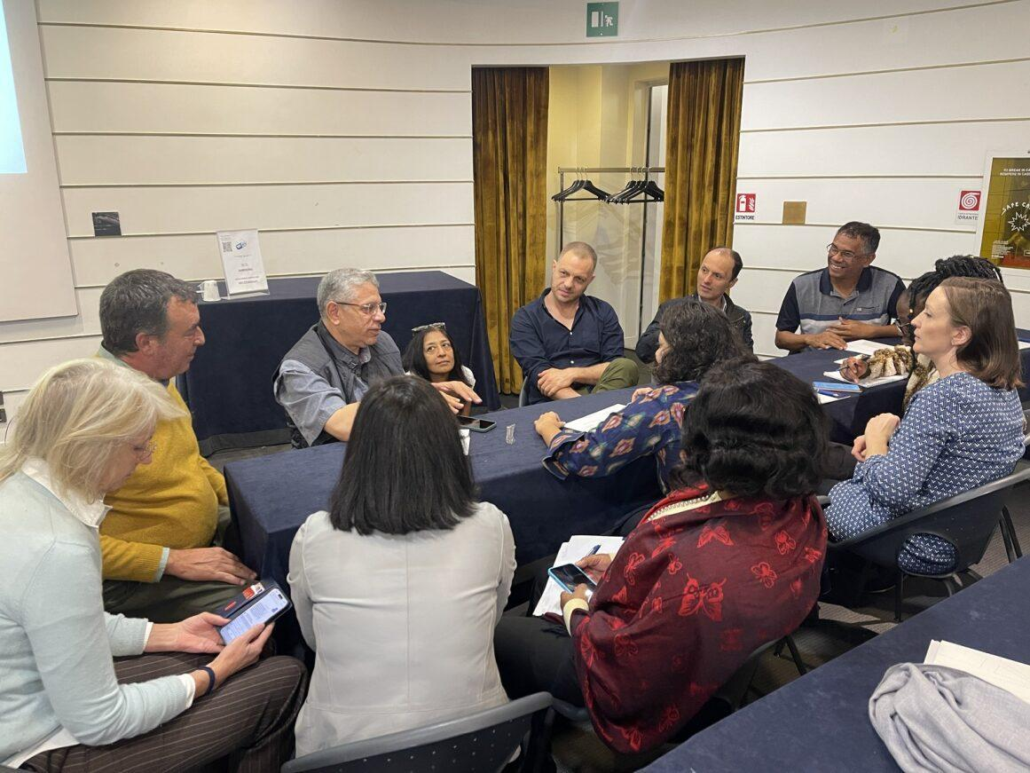
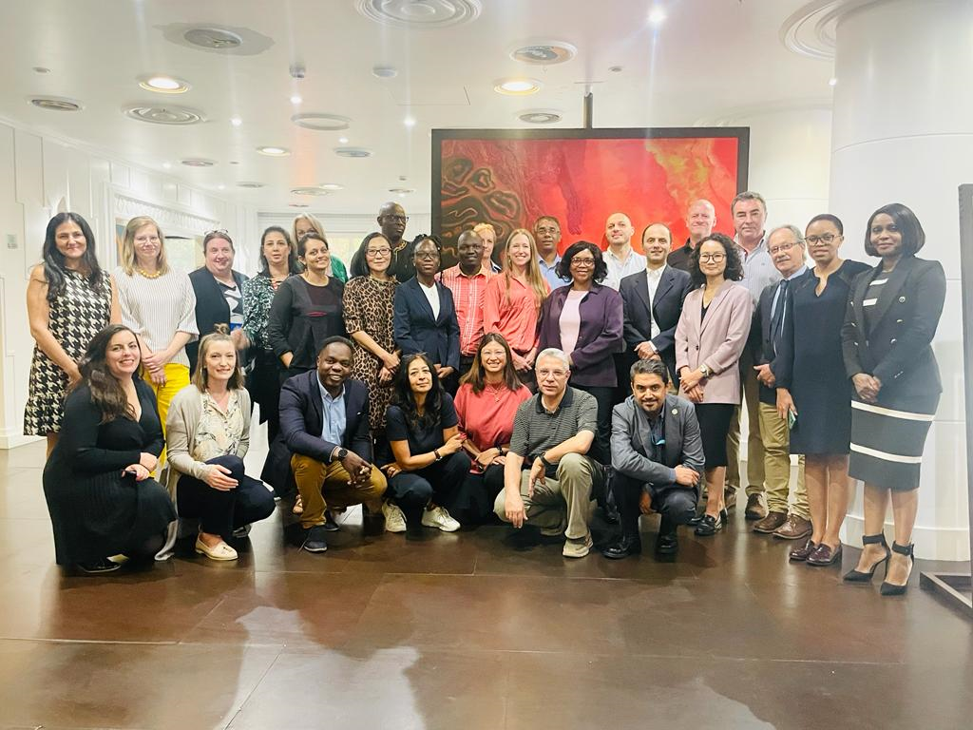

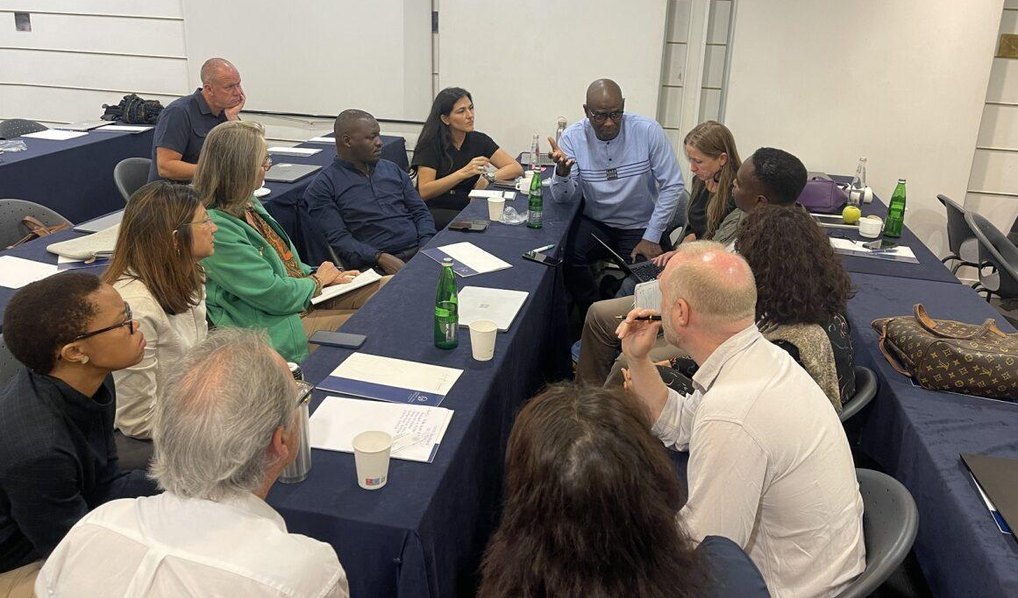

Sustainable Fibre Alliance:
- The 2nd annual Natural Fibre Connect conference, which aims to foster sustainability and innovation in the natural fibre industry, was held in Biella, Italy, on 28–29 Sept. It brought together a large, diverse global community from 39 different countries. The co-chair and other IYRP partners spoke in the Regenerative Agriculture; Rangeland Stewardship Council session, where insights into the IYRP and its significance were shared. The Rangeland Stewardship Council was also unveiled during the conference.
International Livestock Research Institute
- The IYRP participated in the inception workshop of ILRI’s Sustainable Investments for Large-Scale Rangeland Restoration (STELARR) project on 24–25 Oct in Rome, Italy, which was held back-to-back with the UNCCD workshop on rangelands. The project seeks to harness commercial-sector finance for rangeland restoration through sustainable livestock value chains.
Grassland Society of Southern Africa (GSSA)
- Dr Igshaan Samuels, IYRP co-chair, delivered a keynote address on “International Year of Rangelands and Pastoralists – insights into this unprecedented journey” at the GSSA’s annual congress held on 24–26 July in Rustenburg, South Africa. He reiterated the significance of the IYRP and particularly for those in Africa who continually bear the brunt of pressures from other land uses and land users as well as from climate change and various social issues. In South Africa, where rangelands cover about 75% of the country, a concerted effort will now be made to develop a national action plan to support the objectives of IYRP 2026.
Perspectives on Pastoralism Film Festival
- In support of the IYRP 2026, CELEP (Coalition of European Lobbies for Eastern African Pastoralism (www.celep.info) issued a call for the 3rd edition of the Perspectives on Pastoralism Film Festival. The 1st edition was launched in Kassel, Germany, in 2019 and the 2nd in Prague, Czechia, in 2022. The films selected for these two editions can be found on the festival website (https://www.pastoralistfilmfestival.com).
- For the 3rd edition, CELEP seeks documentary, narrative or animated films on pastoralism anywhere in the world – both general films (deadline 4 Sept 2024) as well as thematic films related to camelid pastoralism (deadline 6 Dec 2023), biodiversity & conservation (by 4 June 2024) and pastoralist women & girls (by 4 Sept 2024). Films can be submitted online (https://filmfreeway.com/PerspectivesonPastoralismFilmFestival).
- The film-festival team will select films that are made by pastoralists or bring pastoralists’ perspectives on their life and livelihood system. The films should sensitively portray issues faced within pastoralist societies and should reflect the important role of pastoral mobility.
- The selected films will be shown at in-person and online events up to and during the International Year of Camelids in 2024 and the IYRP in 2026.
- The films are available on request, provided that screening is announced as a contribution to preparing for the IYRP. Contacts: Anthony Denayer (a.denayer@vsf-belgium.org) / Ann Waters-Bayer (waters-bayer@web.de).
GASL
- Several IYRP supporters took part in the 13th GASL (Global Agenda for Sustainable Livestock) Multistakeholder Partnership meeting and the Regional Conference on Sustainable Livestock Transformation held in Chiang Mai, Thailand, on 30 Oct–3 Nov. Some members of RISGs organised a side event on the IYRP on 1 Nov.
- It was agreed that the GASL Platform could be important to leverage action leading up to 2026 and how GASL can contribute to the IYRP. The full report on the GSAL event can be found on the IYRP website: https://www.iyrp.info/resources/news

To find out more about IYRP 2026, go to www.iyrp.info or contact iyrp2026@gmail.com

