**Pastoralism film festival and photo exhibition in Brussels**

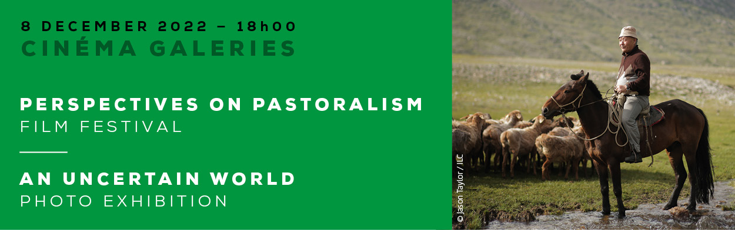

On 8 December 2022, a photo exhibition and films from CELEP’s [“Perspectives on Pastoralism Film Festival”](https://www.pastoralistfilmfestival.com/) were presented in the [Cinema Galeries](https://galeries.be/en/) in the centre of Brussels, Belgium. This event was organised by [VSFB](https://vsf-belgium.org/) (Vétérinaires Sans Frontières Belgium), the [PASTRES](https://pastres.org/) (Pastoralism, Uncertainty & Resilience: Global Lessons from the Margins) research project funded by the European Research Council, and [CELEP](http://www.celep.info) (Coalition of European Lobbies for Eastern African Pastoralism) in support of the [IYRP2026](http://www.iyrp.info).

The first edition of the film festival was launched in September 2019 in Kassel, Germany, with the aim of deepening understanding of this undervalued livelihood and food-production system. The second edition was launched in September 2022 in Prague, Czech Republic. Four of the selected films from the festival were screened in Brussels:

* **An afternoon on the pasture** (Hungary) gives insight into the herding practices of László, a traditional Hungarian shepherd, and his dog.
* **Cowherds of the savannah** (Uganda) shows how Karamojong herders in northeast Uganda manage to turn the sparse vegetation on the rangelands into meat and milk.
* **Shepherds of the Deccan** (India) follows Dhangar nomads on the Deccan plateau in central India, where they face the growing threat of climate change.
* **Bayandalai: lord of the taiga** (Mongolia) explores the largest forest on earth through the eyes of a reindeer herder in northern Mongolia.

After the screening, speakers from three continents commented on the films and shared their experiences with the public. Nitya Ghotge, veterinarian, writer and filmmaker from the Indian NGO [ANTHRA](http://www.anthra.org/), talked about the making of her film *Shepherds of the Deccan* and about these pastoralists’ challenges and expectations. Emmanuel Emaruk, the VSFB Country Director in Uganda, was born in Karamoja, where he works with local people to enhance livestock husbandry and veterinary services. Michele Nori, a tropical agronomist and rural sociologist with the [European University Institute](https://www.eui.eu/en/home), Italy, has studied pastoralist livelihood systems for 25 years and is the co-lead of the PASTRES project. This panel discussion was moderated by Koen Van Troos, the former Focal Point of CELEP in Europe, now with Fairtrade Belgium.

More information about the 30 films selected from the first and second editions of the film festival and the complete catalogue can be found here: [www.pastoralistfilmfestival.com](http://www.pastoralistfilmfestival.com" \t "_blank).

## Photo exhibition “An uncertain world”

Increased market volatility, the climate crisis, rapid technological change, the spread of a pandemic – it’s difficult to keep up with the unfolding reality. And pastoralists are far from being spared. How do they navigate through such an uncertain world? This was the focus of the photo exhibition “An uncertain world”, presented in the exhibition hall of the cinema. A curated selection of images allowed viewers to discover the way pastoralists embrace uncertainty and meet the challenges of a turbulent world. The photos were taken by pastoralists and researchers collaborating in the PASTRES project research sites in China, Ethiopia, India, Italy, Kenya and Tunisia. Additional photos taken by members of CELEP and the IYRP initiative in Eastern Africa were also exhibited by VSFB.