Familiarization workshop on the International Year of Rangelands & Pastoralism (UNIYRP 2026) in Ethiopia
23rd and 24th January 2026, Grand Hall at the Ministry of Agriculture (MOA), Addis Ababa

Concept Note (Final)
15 January 2026

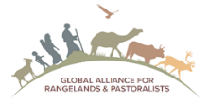
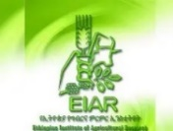
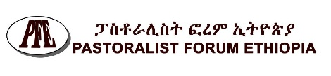
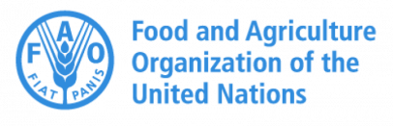


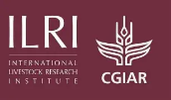
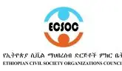
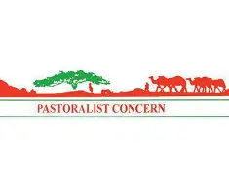
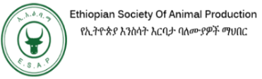
Introduction
Following resolution 5/2021 of the 42nd Conference of the Food and Agriculture Organization of the United Nations (FAO), the United Nations General Assembly (UNGA), at its 76th Session, declared 2026 as the International Year of Rangelands and Pastoralists (IYRP). FAO has been designated as the lead agency for the observance of the IYRP and is responsible for coordinating its implementation in collaboration with Member Nations, United Nations organizations, civil society, the private sector, and other stakeholders. In particular, the IYRP is supported by a coalition of more than 400 pastoralist and supporting organizations as well as many individuals, who mobilized global political support for this resolution, for which the official process was initiated by the Government of Mongolia in 2020. Called the Global Alliance, this coalition's distinctive strengths as a global constituency has set the IYRP apart from previous International Years.
The IYRP aims to raise awareness of the important role that rangelands and pastoralists play in food security, climate adaptation and mitigation, ecosystem health, and rural economies. Rangelands are lands in motion that cover around half of the Earth’s land surface, support unique biodiversity and contribute to the livelihoods and nutrition of millions of people, while being at the heart of their cultural identity. Pastoralists, who move their herds across rangelands to keep both their livestock and ecosystems healthy, are present in 75 % of the countries and are stewards of invaluable Indigenous and local knowledge that teaches lessons for the present and the future. Through strategic mobility, they enhance ecosystem services such as carbon storage, soil fertilization and biodiversity preservation while providing high-quality animal source food. However, these systems are under pressure from land conversion, growing climate-related disasters, ecosystem degradation, and decreasing generational renewal.
Rangelands occupy more than half of the Earth’s land surface and total land mass of Ethiopia. Pastoralism has been practiced for millennia on rangelands as a way for communities to adapt to climatically variable and uncertain environments). According to FAO (2020), there are about 300 million pastoralists and nomadic people around the world while some researchers reported about 25% of the total population of Africa is constituted of pastoralists and agro-pastoralists.
In Ethiopia, pastoralists constitute more than 12 million citizens residing in six national regional states and Dire Dawa City Administration. Pastoralists inhabit the entire lowlands of the country, which constitutes about 60% of the country’s total landmass. The pastoral population is heterogeneous in its ethnic composition and social structure, with 90% of them belonging to the Afar, Oromo, and Somali ethnic groups. Most of these groups are found in the peripheries of the country and have similar lineages with pastoral areas of the bordering areas and peoples in the neighbouring countries.
The official launch ceremony of the IYRP was held on 2nd December 2025, at the FAO Headquarters in Rome, Italy, as part of the 179th session of the FAO Council. The official global inauguration of UNIYRP will be held in Mongolia in August 2026 along with UNCCC 17.
Thus, Pastoralist Forum Ethiopia (PFE) and key stakeholders are spearheading the preparation of this familiarization workshop on the IYRP 2026 in Ethiopia.
Purpose and objective of the workshop
Funded by the European Union, mainly through the FAO-implemented PLACE programme, the purpose of the workshop is to raise awareness of the UN International Year of Rangelands and Pastoralists (IYRP) in Ethiopia and globally. The workshop is partly funded by AAU-IPSS.
The objectives of the workshop are to:
- Create awareness on the IYRP for wider range of pastoralist and pastoral stakeholders
- Draw lessons from pastoral and rangelands development in Ethiopia
- Recommend future development direction of pastoral and rangelands development in Ethiopia
- Propose submissions for the global actions of IYRP 2026 and inauguration in Mongolia August 2026
The Workshop Setting
Workshop venue, date and participants
The workshop will be held for two days in Addis Ababa on 23rd and 24th January 2026 at MOA Grand Hall Addis Ababa. The total participants are about 150+ mainly pastoralist representatives from the Ethiopian side of the Karamoja and Mandera clusters and key stakeholders in the regional event on IYRP.
The composition of participants including women and youth representation and generally set as follow and please note complete list participants is found in Excel file annexed
- Pastoral representatives from Somali region including two organizers (7)
- Pastoral representatives from South Omo (7)
- Afar pastoralist representatives (5)
- Oromia pastoralists (5)
- Parliamentarians and Government organs (18)
- International community including EU and FAO (11)
- Academic and research institutions (12)
- CSOs (21)
- Private sectors (3)
- Media (10)
- Key individuals (8)
- Organizers and admins (10)
Opening Ceremony (Welcoming messages, Keynote addresses, and Opening Speech) MC: Dr Getachew Gebru, Senior Researcher
- Pastoralist Elders blessing (representatives of elders’ pastoralist)
- Welcoming Address: Hadji Abdi Abdulahi Hussien (PFE Board Chairperson)
- Message from IYRP: Prof. Igshaan Samuels (Global Alliance for Rangelands and Pastoralists) (Online)

Moderator: Tezera Getahun, ED, Pastoralist Forum Ethiopia

- Keynote One: FAO representative
- Keynote Two: EU representative
- Opening Speech: H.E Dr Fikru Regassa, State Minister, MOA

Moderator: Dr Berhanu Admasu, Senior Researcher
High-level policy discussion (opportunities for development of pastoralism and rangelands, and roles and responsibility of key actors to support IYRP
Moderator: Dr. Mercy Fekadu, AAU-IPSS Director
- Hon. Ms. Fetiya Ahmed Shire, Chairwomen, Water, irrigation lowland and environments development Standing Committee.
- H.E. Dr. Fikru Regassa, State Minister. MOA
- H.E. Fasikaw Molla, D/CEO, Authority of Civil Society Organizations (ACSO)
- Hadji Abdi Abdulahi Hussien, PFE Board Chairperson
- Prof. Gebre Yntiso Deko, Professor of Anthropology
Paper presentation
- Global perspectives of pastoralism (Dr Berhanu Admasu, Researcher
- Genesis of IYRP and Global Action Plans of IYRP (Tezera, PFE)
- Unique case study(ies) from South Omo pastoral communities (Bardoley/Barkede/Olisarali)
- Lessons drawn from pastoral and rangelands development in Ethiopia (Dr Abula Ebro, ILRI/ESAP, Ethiopian Society of Animal Production)
- Current dynamics and future of pastoralism (Abdi Abdulahi Hussien, PFE)
- CSO roles in the implementation of IYRP (Ahmed Hussien, ECSOC)

Panel Discussion
Topic: Key challenges of rangeland development; expectations from IYRP 2026, and takeaways for UNFCC and IYRP launching in Mongolia
- Abdulkadier Sheh Maha, PAPDA, CSO
- Chane Gebeyehu, LLRP-MILLs
- Dr. Abule Ebro/ESAP
- Dr Samual Tufa, ATI
- Mr. Barkede Kulu (S.Omo)

Establishment of “UNIYRP 2026 Chapter of Ethiopia”
This chapter will be established with TOR and structure to support IYRP activities and follow up.
Roles and responsibilities of stakeholders
The proposed structure and members of ad hoc Organizing Committee of the workshop are MOA Chair; PFE Co-Chair; ESAP Secretary; FAO representative member; IPSS Member; and Pastoralist Concern (PC) member.
- Draft the TOR of the conference (PFE and shared to organizing committee)
- Select and Invite participants and presenters, and journalist (PFE and ESAP)
- Set workshop venue and catering (PFE and ESAP)
- Perform All admin works (PFE and ESAP)
- Audio visuals and proceeding production (PFE and ESAP)
- Financial cost breakdown and management (PFE and IPSS)

Finance management
The financial costs of the workshop are covered by PFE, MOA-DRIVE, and AAU-IPSS and they will work on the financial breakdown and management. There may be possibilities that some key stakeholders could contribute in finance and technical terms for instance covering part of costs of transportation for selected participants. Some partners have been already communicated to assist us in selection and arranging transportation of pastoralist coming to the workshop from pastoral areas.

