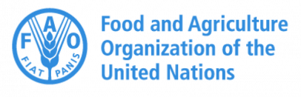 | 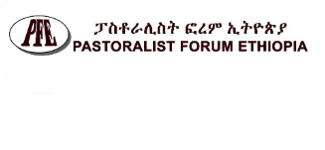 | 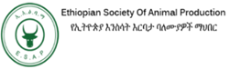 | 
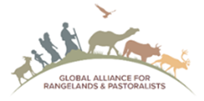
Familiarization workshop on International Year of Rangelands and Pastoralism (UNIYRP 2026) in Ethiopia
23rd and 24th January 2026, Grand Hall, MOA, Addis Ababa
DAY ONE: FRIYDAY, 23rd Jan 2026
S/N | Particular | Time | Responsible | Coordinator/Moderator
1. | Registration | 08:30-09:00 | PFE/ESAP | Abebe and Ms Emebet
2. | Opening Ceremony  (LEAD: Dr. Getachew Gebru/ESAP) | 09:00-10:20 | Welcome and Program Introduction | Tezera-PFE
 | - Elders blessing |  | Elders Pastoralist
 | - Welcoming address |  | Hadji Abdi Abdulahi Hussien (PFE Board Chairperson)
 | - Message from IYRP |  | Prof. Igshaan Samuel, Vice Chairperson of Global Alliance for Rangelands and Pastoralists (Online)
 | - Keynote One |  | FAO representative | Dr Berhanu Admasu, Researcher
 | - Keynote Two |  | EU representative
 | - Key Note Three |  | ILRI Representative
 | - Opening Speech |  | H.E Dr. Fikru Regassa, State Minister, MOA
3. | High-level policy discussion (opportunities for development of pastoralism and rangelands, and roles and responsibility of key actors to support IYRP | 10:20-11:30 | - Hon. Ms. Fetiya Ahmed Shire, Chairwomen, Water, irrigation lowland and environments development Standing Committee.  - H.E. Dr. Fikru Regassa, State Minister. MOA  - H.E. Fasikaw Molla, D/CEO, Authority of Civil Society Organizations (ACSO)  - Hadji Abdi Abdulahi Hussien, PFE Board chair  - Prof. Gebre Yntiso Deko, Professor of Anthropology | Dr. Mercy Fekadu, Addis Ababa University-IPSS Director
4. | HEALTH BREAK AND EXIBITION AND PRAYER | 11:30-13:00 | Various promotional materials displayed | Organizers/Workalemahu PC
5. | LUNCH BREAK | 13:00-14:00 |  | Organizers
6. | Paper Presentations and Discussion | 14:00-16:30 |  | Beruk Yemane, PFE
 | - Global perspectives of pastoralism |  | Dr. Birhanu Admasu, Researcher
 | - Lessons drawn from pastoral and rangelands development in Ethiopia |  | Dr. Abula Ebro, ESAP
 | - Current dynamics and future of pastoralism |  | Hadji Abdi Abdulahi Hussien, PFE Board Chairperson
 | - Unique case studies from South Omo pastoral community (ies) |  | Bardoley/Barkede/Olisarali, South Omo
7. | HEALTH BREAK AND CLOSE OF DAY ONE | 16:30-17:00 |  | Organizers
DAY TWO: SATURDAY, 24th Jan 2026
8. | Registration | 08:30-09:00 | PFE/ESAP | Abebe and Ms. Emebet
9. | Paper Presentations and Discussion | 09:00-1030
 | - CSO roles in the implementation of IYRP |  | Ahmed Hussien, Board Chairperson CSO Council (ECSOC) | Dr. Diriba Geleti, D/CEO, EIAR
 | - Genesis and Global Action Plans of IYRP |  | Tezera Getahun, PFE
10. | PANEL DISCUSSION:  Key potentials and challenges of rangeland development in Ethiopia; expectations from IYRP 2026, and takeaways for UNFCC and IYRP launching in Mongolia |  | - Mr. Abdulkadier Sheh Maha, PAPDA, CSO  - Mr. Chane Gebeyehu, LLRP-MILLs  - Dr. Samuel Tufa, ATI  - Mr. Barkede Kulu (S.Omo)  - Dr Abule Ebro, ESAP | Dr. Daniel Temesgen, ESAP President and Chairperson of Alliance of Professional Associations
11. | HEALTH BREAK | 10:30-11:00
12. | Establishment of Country Chapter of UNIYRP 2026 | 11:00-12:00 | Organizing body | Tezera Getahun, PFE
13 | General discussion and wrap up | 12:00-12:30 | Dr. Daniel, Hadji Abdi Abdulahi, and Tezera | Beruk Yemane, PFE
14. | CLOSING | 12:30-13:30 | Prof. Nigussie Dechasa, CEO, EIAR | Tezera PFE
15. | LUNCH BREAK | 13:30 |  | Organizers

