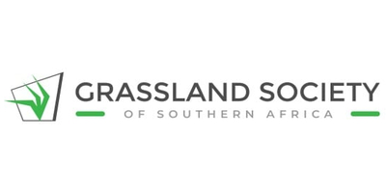

Dear Igshaan,

We are excited to announce that the 61st Annual Congress of the Grassland Society of Southern Africa will be held from 20 - 24 July 2026 at Houw Hoek Hotel, Grabouw in the Western Cape, South Africa.

We look forward to hosting an exciting programme and workshops celebrating the International Year of Rangelands and Pastoralists.

Follow us on Facebook or visit the conference website for more information coming soon!

Be sure to mark our event on your calendar and share this information with your mailing lists.

Kind Regards

Minette van Lingen
Administrator

