International Year of Rangelands and Pastoralists (IYRP) 2026 – Journey Launch
The IYRP 2026 journey was formally launched on January 1, 2026, at 6:00 a.m., during sunrise at Kanyakumari Beach, the southernmost tip of India. The gathering was marked by prayers and a collective assertion of pastoral rights. As part of the IYRP 2026 action plan, an awareness journey addressing the key questions “Who are pastoralists?” and “What are rangelands?” will be undertaken across Tamil Nadu. Continuing the journey, at 10:00 a.m., the Taluk-level Pastoralists’ Association was inaugurated at Radhapuram Taluk, Tirunelveli District. The event was attended by Pakshirajan, Advisor, Tamil Nadu Federation of Pastoral Peoples’ Sangams (TFPPS), Vivekanandan Perumal Seva Organization, Ravi Challam, Coexistence Consortium, Bengaluru, Mathivanan M., Sr. Research Associate and Coordinator, Leaders of farmers’ associations, natural farmers, pastoral activists, and members of pastoral communities. The IYRP 2026 journey will continue across Tamil Nadu, including the Western Ghats, Eastern Ghats, and major river basin regions such as Vaigai, Cauvery, and Thamirabarani, to highlight the ecological, social, and economic importance of pastoralism and to work towards its revitalization.
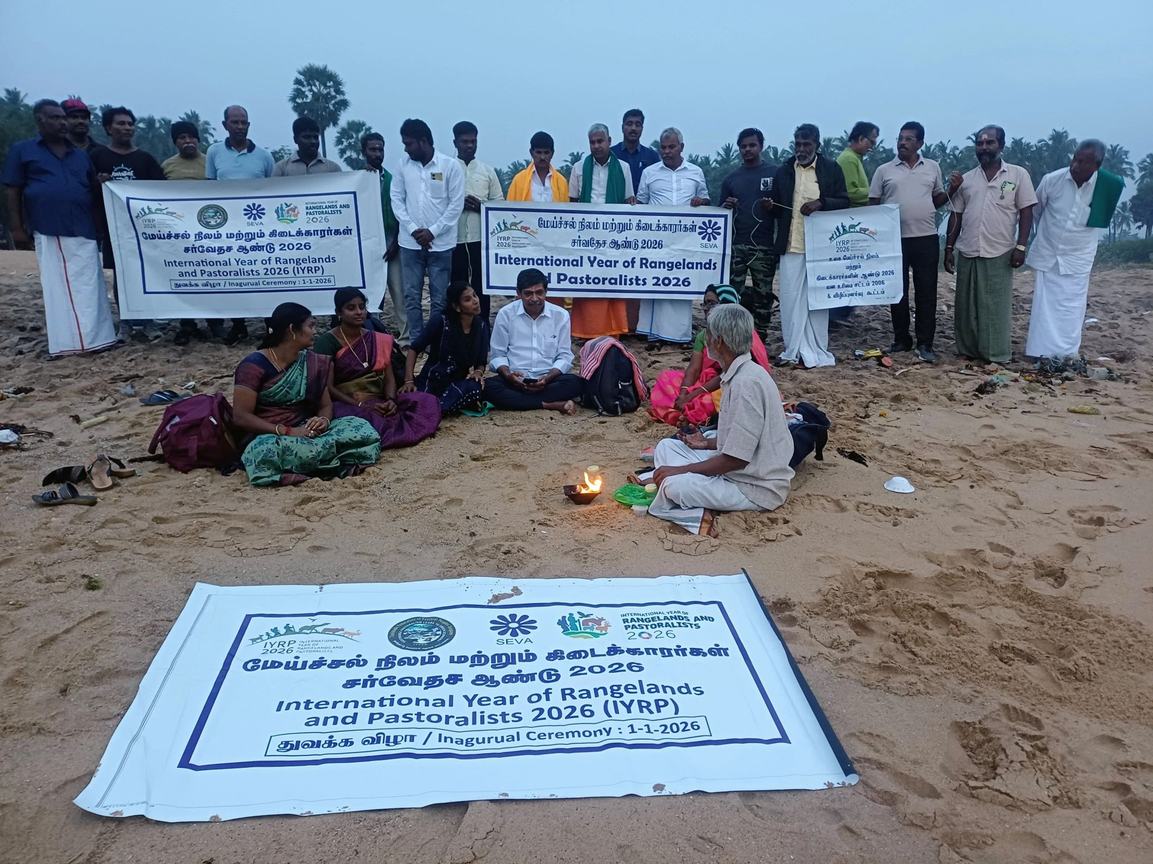
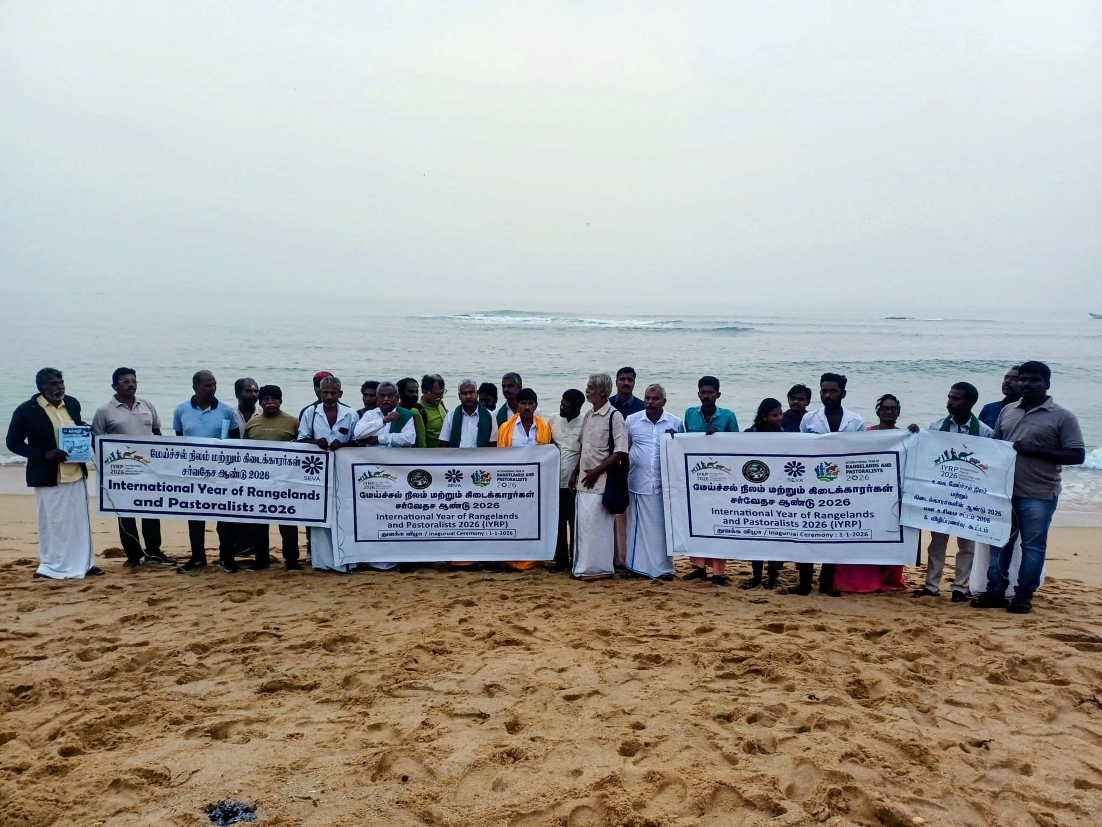
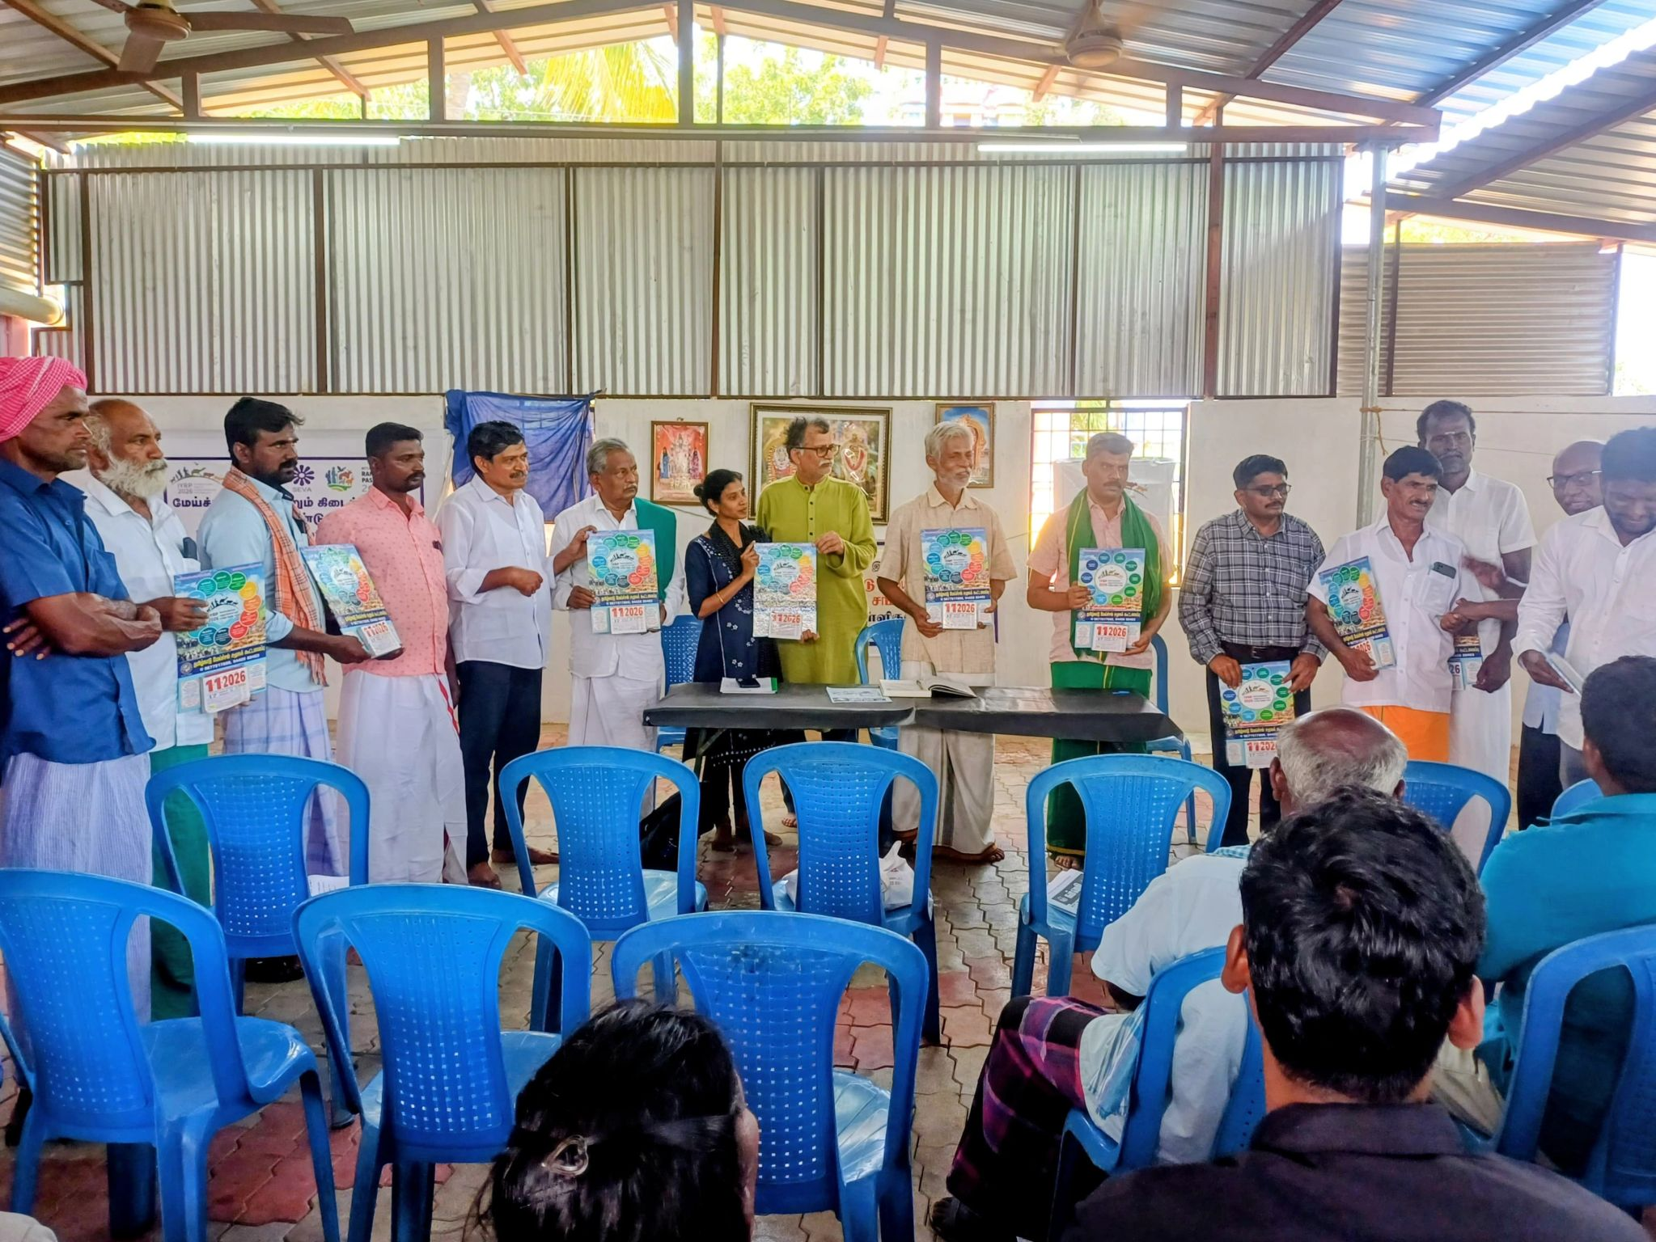
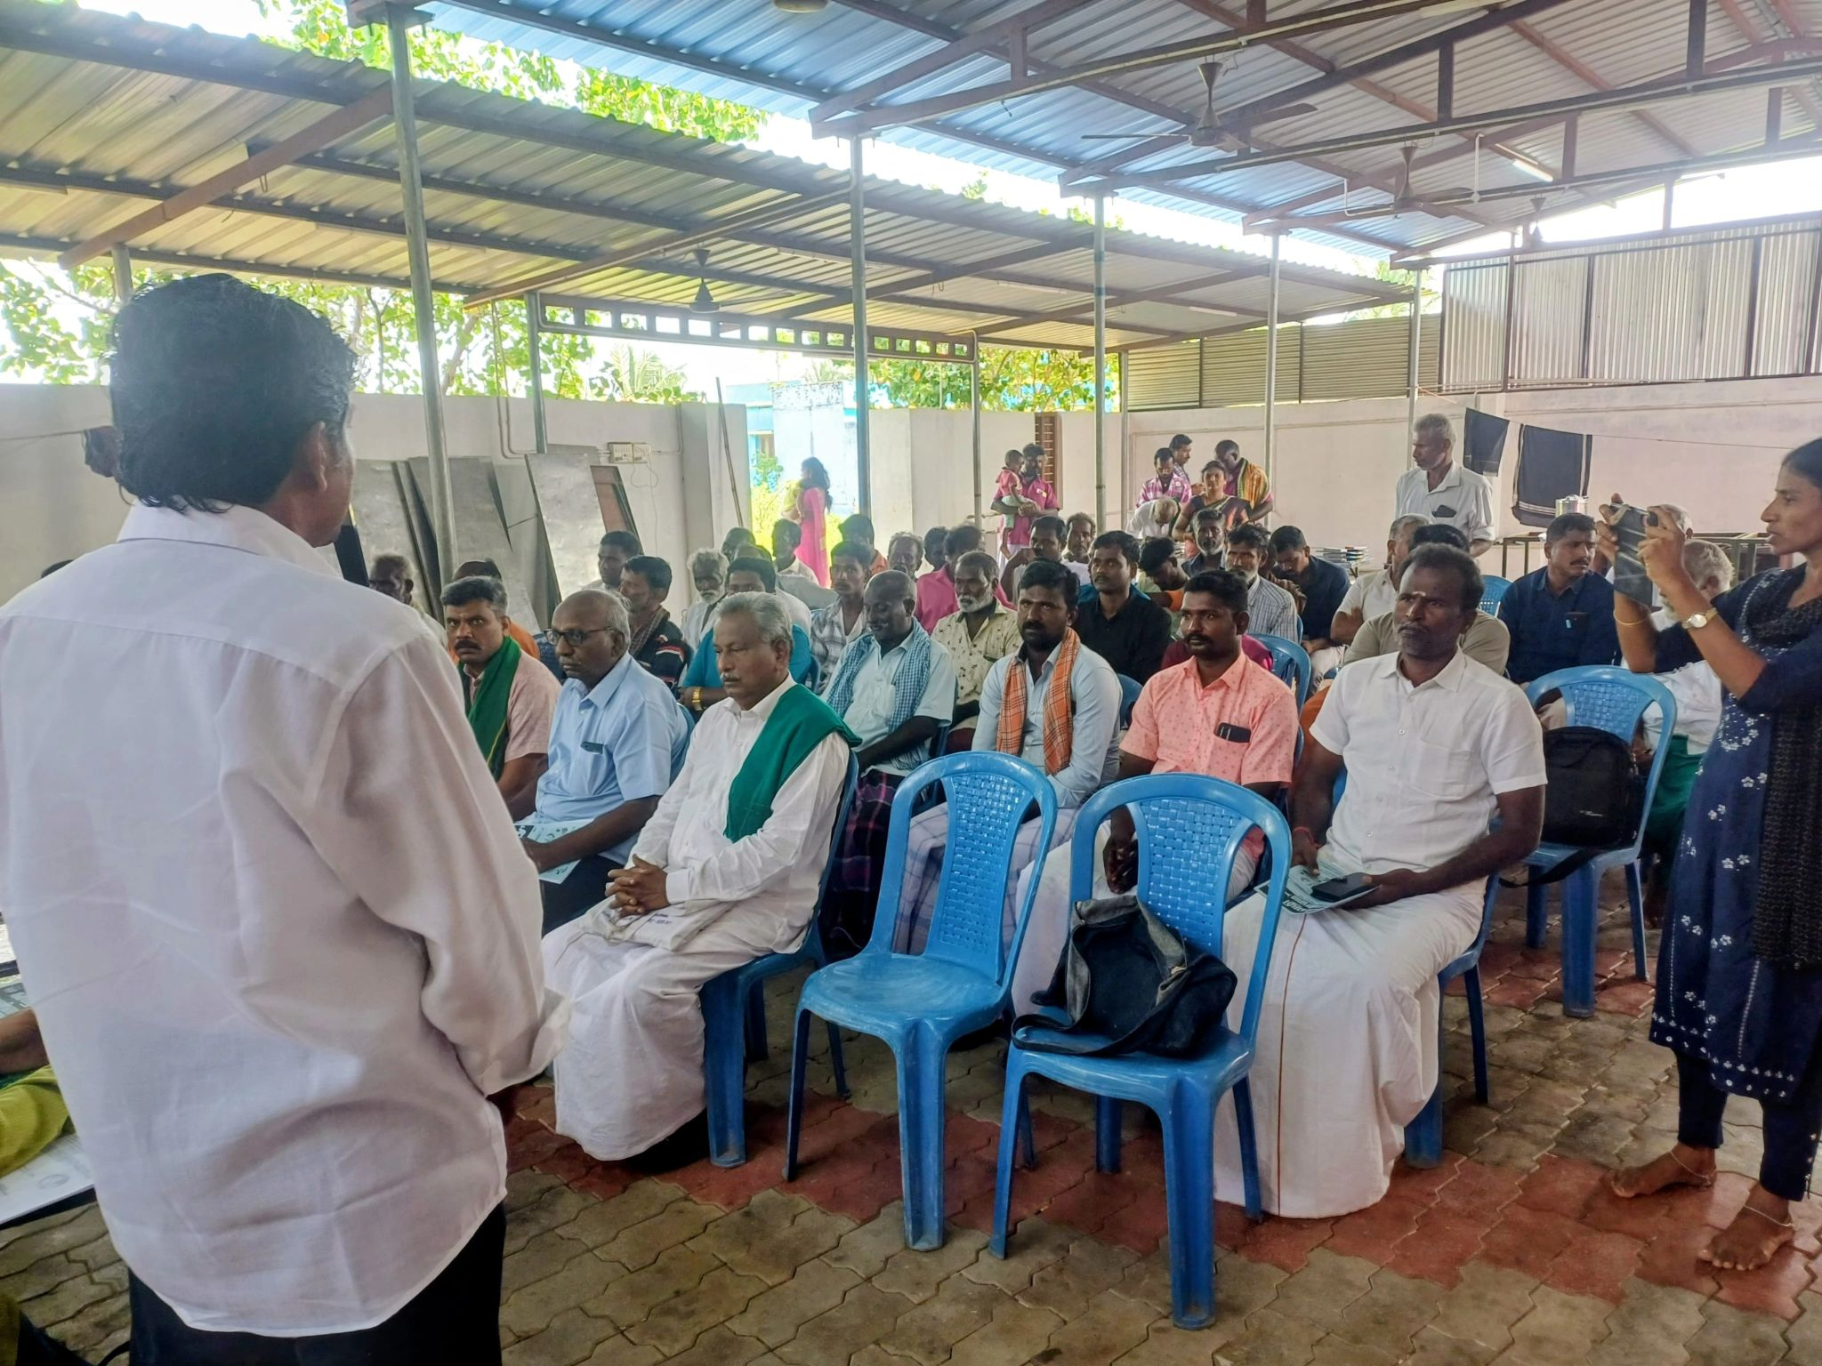

Empowering the Pastoral Communities of Thoothukudi: Launch of the Srivaikuntam Taluk Pastoralists Sangam
​ We were proud to announce the official inauguration of the "Srivaikuntam Taluk Sheep and Cattle Pastoralists Sangam" today (January 7, 2026) in the Thoothukudi District. ​By uniting the traditional pastoral communities around the Vallanadu hill region, this Sangam was established as a vital member of the Tamil Nadu Federation of Pastoral Peoples’ Sangams. Our mission was to serve as a resilient voice for the protection of livelihoods and the reclamation of traditional grazing and forest rights. ​Our objective were, a) Strengthening the collective power of pastoralists across the Srivaikuntam Taluk through the Sangam network. b) Collaborating with government agencies to introduce modern pastoral techniques and welfare schemes for sheep and cattle rearing. c). Reviving degraded grazing lands by planting native fodder and trees to restore the local ecosystem. d). ​Resource Access: Working with authorities to ensure water security for livestock along traditional migratory routes. e). ​Taking decisive legal action against the encroachment of common grazing lands and water bodies. f). ​Forest Rights: Securing and reclaiming grazing rights in accordance with the Forest Rights Act (FRA) 2006. g). ​Creating direct market linkages to ensure fair prices for livestock products produced by our pastoralist members. We invited all pastoralists, environmental advocates, and stakeholders in the Vallanadu region to join our Sangams. Together, under the state federation, we will build a sustainable and empowered future.
