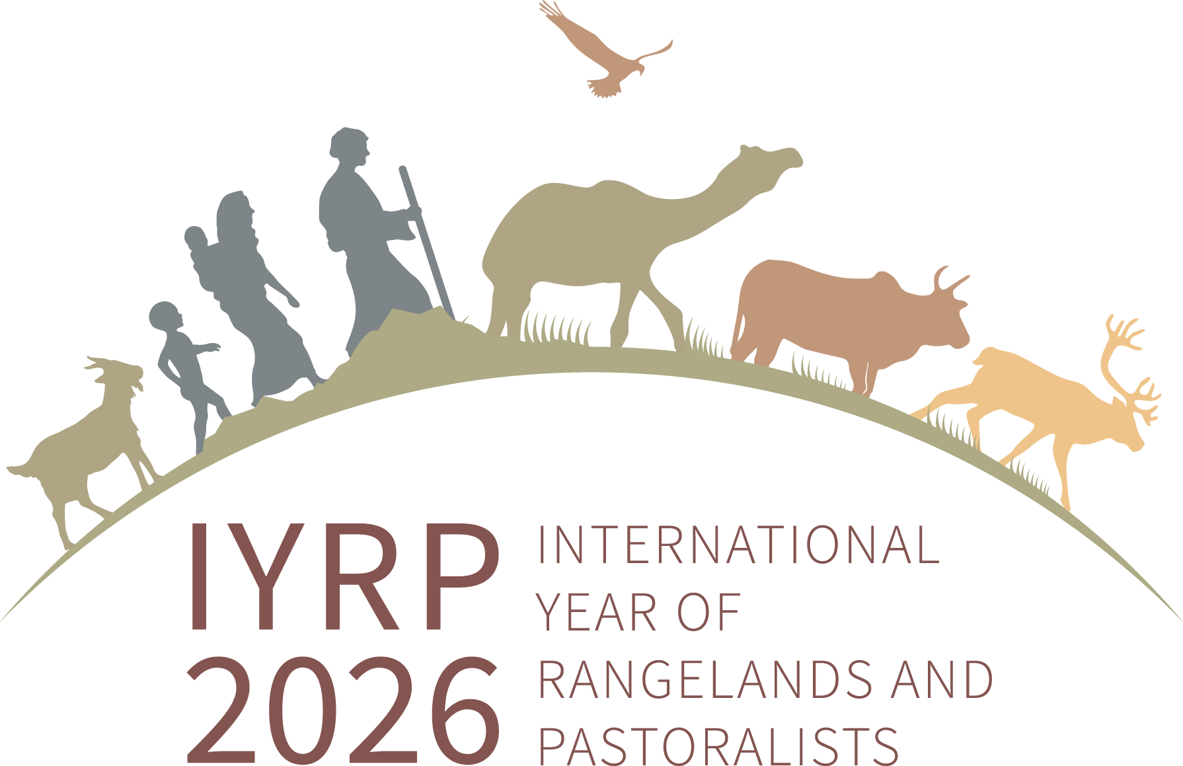

Society for Range Management Annual Meeting
Monterey, CA – 7-11 February 2026

Ignite Session: The 12 global themes of the International Year of Rangelands and Pastoralists (IYRP2026)

Date: 10th February 2026 10:20 am to Noon California time

Organizers: Maryam Niamir-Fuller (mniafull2@gmail.com) and Maria Fernandez-Gimenez (maria.fernandez-gimenez@colostate.edu)

Session Description: Objectives of the IYRP 2026 are to raise awareness about the value of healthy rangelands and sustainable pastoralism, generate new knowledge, and positively impact laws and policies. The IYRP Global Alliance has adopted 12 themes, one for each month of 2026, that capture the full spectrum of sustainability - social, economic, environmental and governance. During 2024-25 special IYRP Working Groups consisting of scientists, practitioners and pastoralists developed key recommendations for each theme. The Ignite Session will review these key messages, pointing out challenges and opportunities across the globe, and offering practical solutions for stakeholders to adopt in the coming decade.
AGENDA
10:20-10:25 Introduction and session overview
10:25-10:30 IYRP Theme 1: Who are pastoralists and what are rangelands?
10:35-10:40 IYRP Theme 2: Mobility, land and water security
10:40-10:45 IYRP Theme 3: Livelihoods and economics
10:45-10:50 IYRP Theme 4: Climate and resilience
10:50-11:00 Q&A and Discussion 1
11:00-11:05 IYRP Theme 5: Biodiversity and ecosystem services
11:05-11:10 IYRP Theme 6: Sustainable rangeland uses and restoration
11:10-11:15 IYRP Theme 7: Services and infrastructure by and for pastoralists
11:15-11:20 IYRP Theme 8: Indigenous knowledge, culture and innovation
11:20-11:20-12:30 Q&A and Discussion 2
11:30-11:35 IYRP Theme 9: Benefits to society
11:35-11:40 IYRP Theme 10: Pastoralist women
11:40-11:45 IYRP Theme 11: Pastoralist youth
11:45-11:50 IYRP Theme 12: Innovative solutions for a sustainable future
11:50-12:00 Q&A and Discussion 3

