Sustainable management of grassland and pastoralists' livelihood
International Year of Rangelands and Pastoralists Session, Annual Meeting of Chinese Grassland Society on October 12，2025， Qingdao，China
（Chaired by Guodong Han，Ruping Rong，and Ruijun Long）

On October 12, 2025, the International Year of Rangelands and Pastoralists session of the Chinese Grassland Society was successfully held in Qingdao, Shandong Province, China. As an important part of the annual meeting of Chinese Grassland Society, this session centered on the core theme of the International Year of Rangeland and Pastoralists, gathered domestic experts and scholars in the fields of grassland ecology, livestock economy, ethnic culture, and which was held on time at 8:00 a.m. on the same day. Through the combination of academic reports and roundtable forum, we deeply discussed the key issues of synergies between global grassland protection and herdsmen's livelihood, and warmed up and stored energy for the International Year of Rangelands and Pastoralists to be held in 2026, in Mongolia.
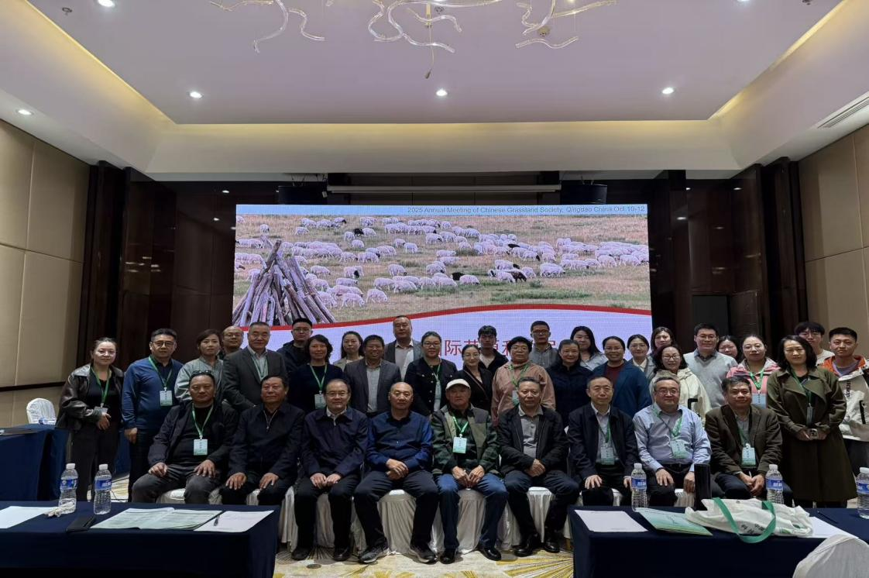
Academic reports: Multi-dimensional analysis of critical issues in rangelands and pastoralists development
At the beginning of the sub-venue, experts and scholars from many scientific research institutes and herders across the country delivered presentations in turn, sharing the latest research results and practical experiences from multiple dimensions such as ecological theory, policy implementation, technological innovation and cultural heritage.
Prof. Long Ruijun from the School of Ecology of Lanzhou University took the lead in opening the talk, systematically sorting out the background, objectives and global significance of the establishment of the 2026 International Year of Rangelands and Pastoralists by the United Nations with the title of ‘Talking about the International Year of Rangelands and Pastoalists‘. He highlighted that grasslands and rangelands cover 54% of the world's terrestrial area, present in 66% of countries. These ecosystems support the livelihoods of 2 billion people and sequester 30% of the planet's terrestrial carbon. In view of the current threats faced by grasslands such as climate change, overgrazing and rural-to-urban youth migration, he called for strengthening grassland protection through international cooperation, promoting the sustainable development of the four-in-one grassland and animal husbandry ecosystem of‘plants-animals-microorganisms-herdsmen‘, and introduced the preparation progress of IYRP East Asia and the direction of China's participation.
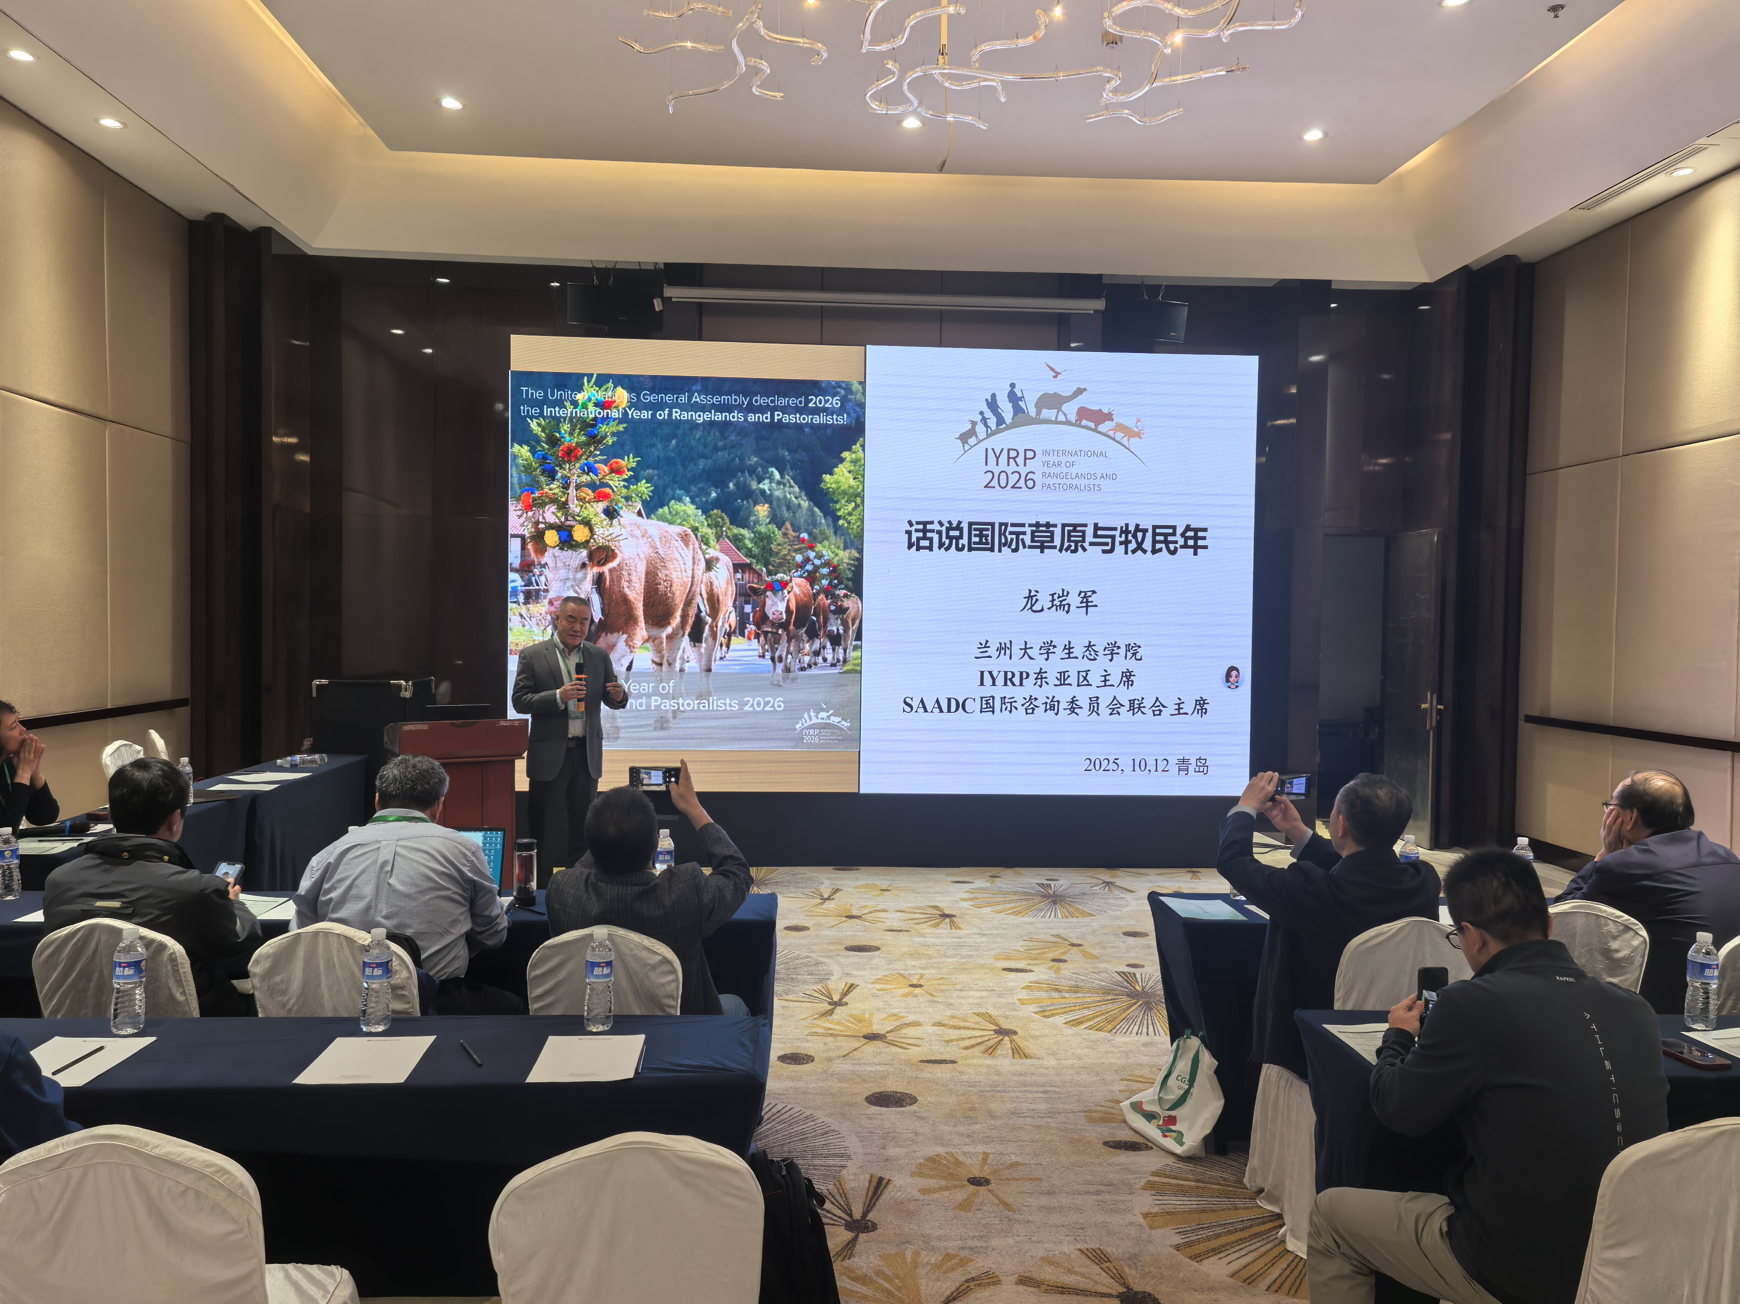
Based on the three-stage panel data of Urad Middle Banner, Bayannaoer City, Inner Mongolia, Prof. Tan Shuhao's team of Renmin University of China found through stochastic frontier model and mechanism test that the new round of grassland tenure confirmation can significantly improve the technical efficiency of animal husbandry by encouraging herdsmen to actively use grassland and promoting grassland circulation, thus providing empirical support for the optimization of grassland property rights system. She suggested further improving the grassland transfer trading platform, strengthening policy dissemination with the help of digital technology, and enhancing the awareness of herdsmen's property rights security.
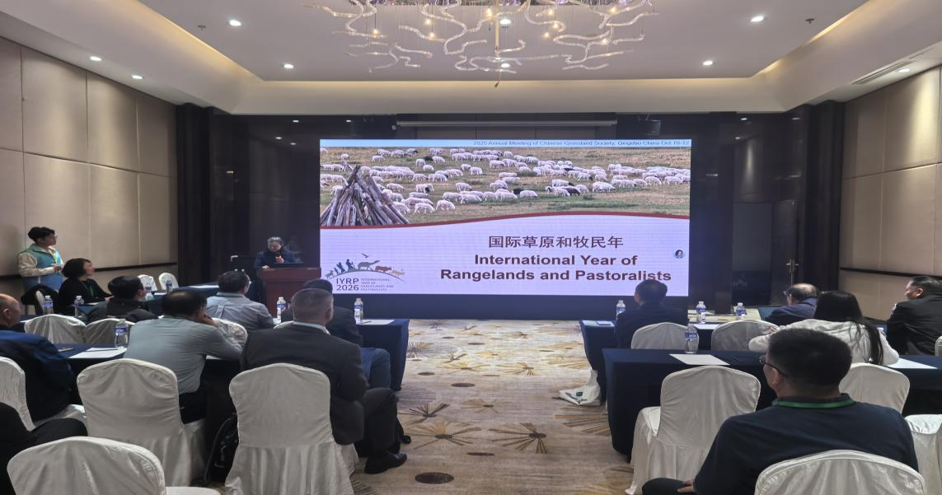
Wang Mingli, a researcher at the Chinese Academy of Agricultural Sciences, discussed the topic of ‘The Road to Transformation, Upgrading and Modernization of China's Grassland Animal Husbandry’, summarized the phased achievements of China's grassland ecological protection and restoration, transformation of production and management mode, and industrialized brand building, and pointed out the bottlenecks such as weak links in the industrial chain, insufficient scientific and technological support, and imperfect policy and market system. He proposed five key priorities: ‘Strengthening Foundations, Upgrading Quality, Enhancing Benefits, Prioritizing Herder Well-being, and Expanding Focus Areas.‘ He emphasized the need to cultivate local scientific talent, improve joint epidemic prevention and control mechanisms, and foster the deep integration of primary, secondary, and tertiary industries to build a modern grassland animal husbandry system that balances ecological sustainability with increased herder incomes.
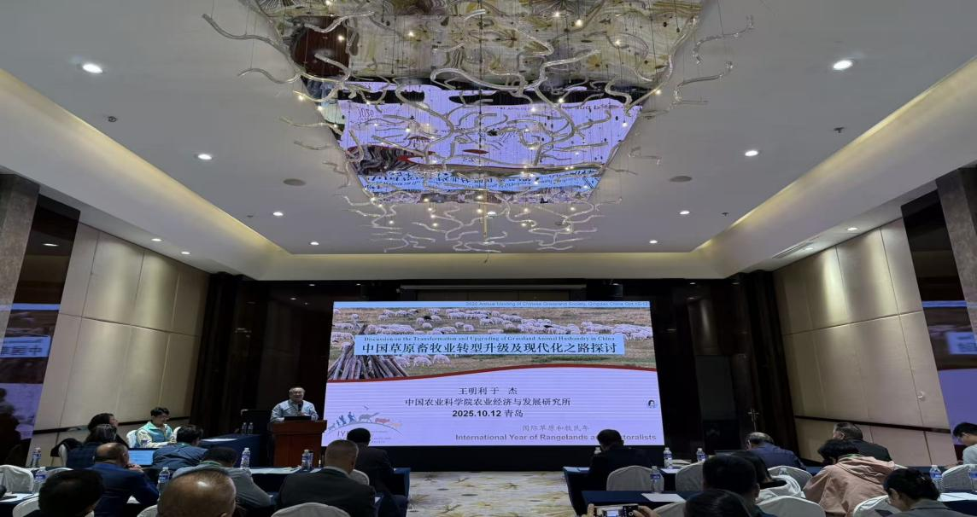
Prof. Hou Xiangyang's team of Shanxi Agricultural University innovatively put forward the concept of ‘psychological stocking rate’ with the title of "Influencing Factors, Ecological Effects and Countermeasures of Grassland Herdsmen's Overload and Livestock Reduction’, revealing that the psychological stocking rate of herdsmen is generally higher than the balance standard of grass and livestock, which is the internal reason for long-term overload. By comparing the practices of grassland ecological restoration in China and Mongolia, he suggested establishing a long-term mechanism for herdsmen to reduce livestock independently, scientifically adjusting the ecological compensation policy, and implementing targeted measures to promote the balance between grass and livestock.
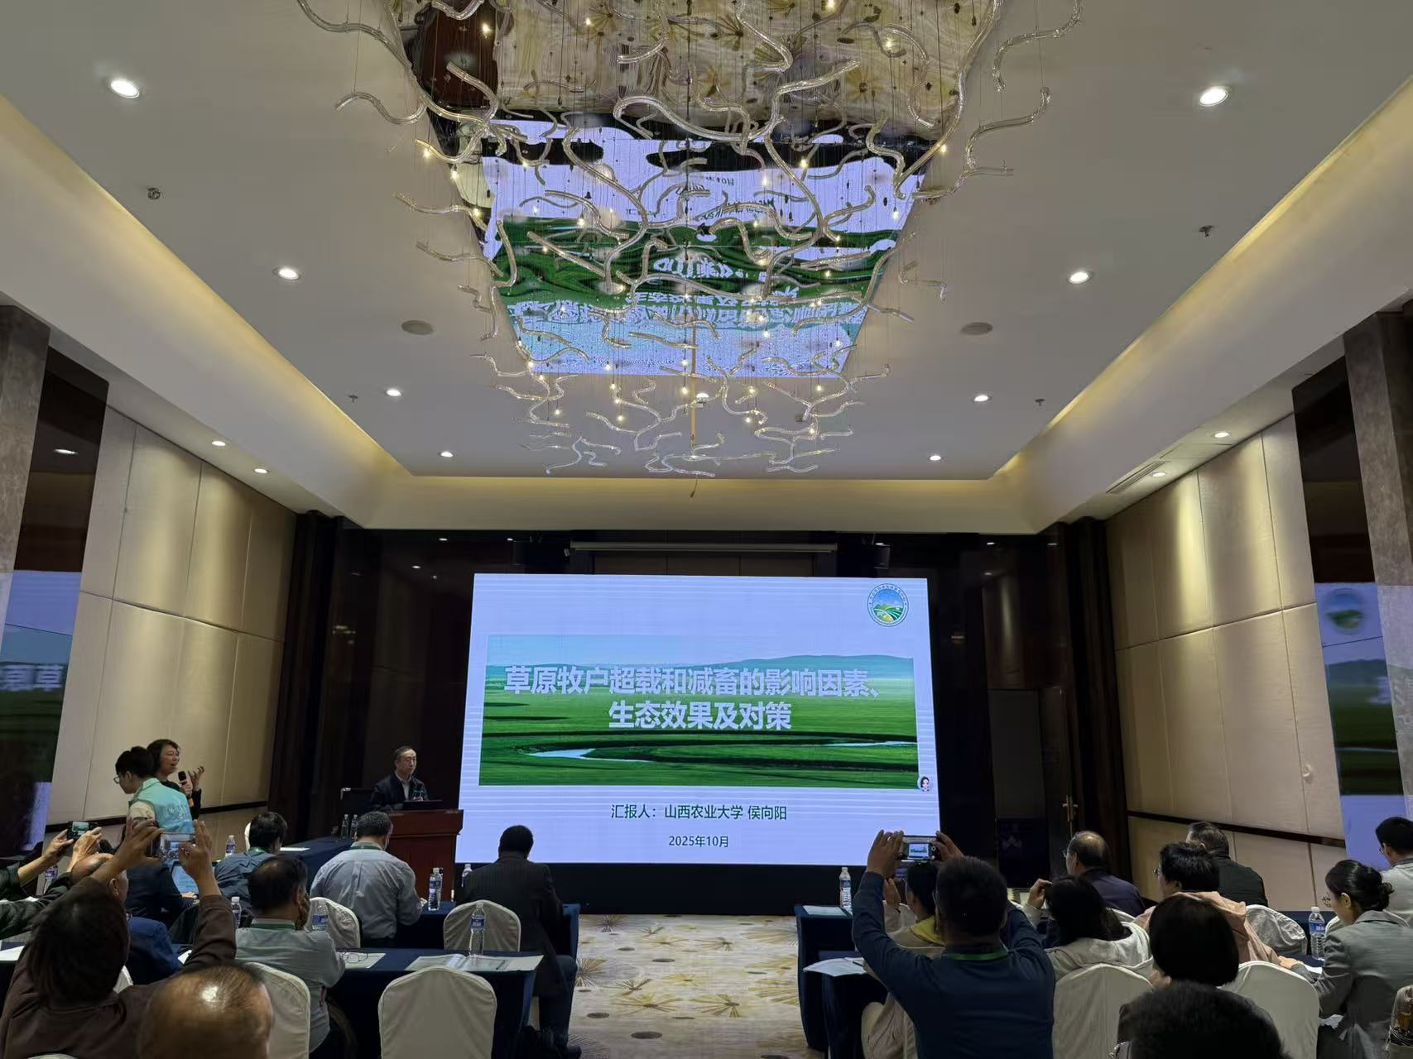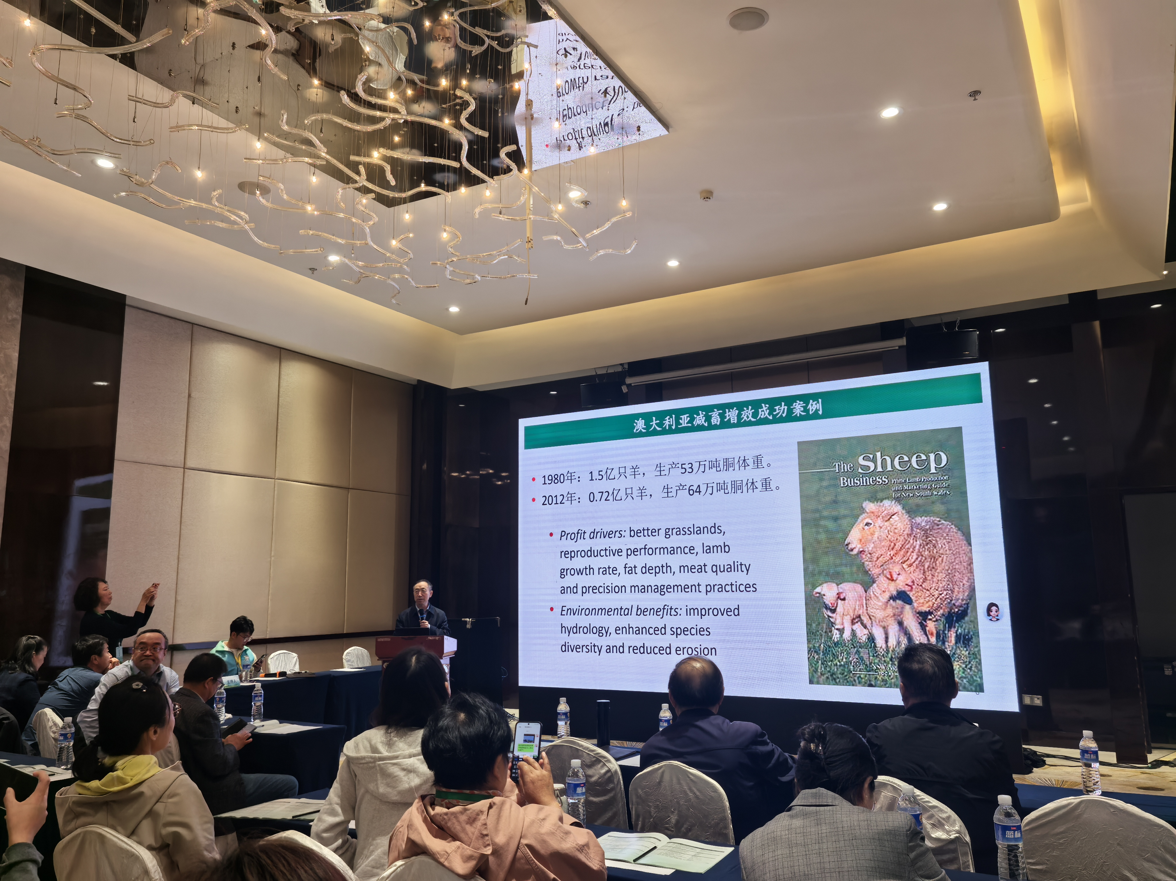
The session also featured presentations from a wide array of experts who shared theoretically profound and practically valuable research, offering diverse solutions for grassland conservation and pastoralist development. The topics included: the evolution of grassland management theories (Prof. Dong Shikui, Beijing Forestry University); adaptive grazing technologies (Prof. Li Yonghong, Inner Mongolia University); the current status of pastoral regions in Xinjiang (Prof. Sun Zongjiu, Xinjiang Agricultural University); energy balance in crop-livestock systems on the Loess Plateau (Prof. Hou Fujiang, Lanzhou University); innovation for new quality productive forces in grasslands (Prof. Wang Ling, Northeast Normal University); willingness to pay for grassland insurance (Prof. Tang Jianjun, Renmin University of China); synergistic development of grasslands and pastoralists (Prof. Rong Yuping, China Agricultural University); case studies on the transition and upgrading of grassland animal husbandry (Bayas Huliang, Inner Mongolia Academic Workstation of Orodos); production technologies for eco-friendly cashmere (Researcher Zhi Rong, Chinese Academy of Agricultural Sciences); herder participation in ecological governance (Researcher Liu Gang, Sichuan Academy of Grassland Sciences); traditional ecological culture on the Tibetan Plateau (Prof. Shang Zhanhuan, Lanzhou University); and carbon management in the Hindukush-Himalayan region (Prof. Shang Zhanhuan, Lanzhou University).
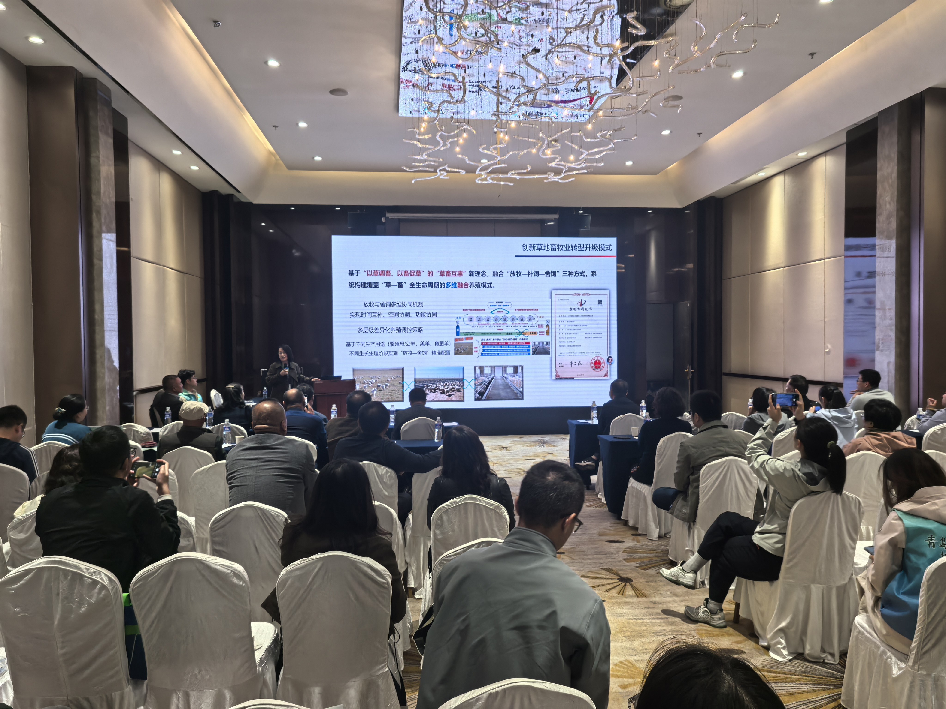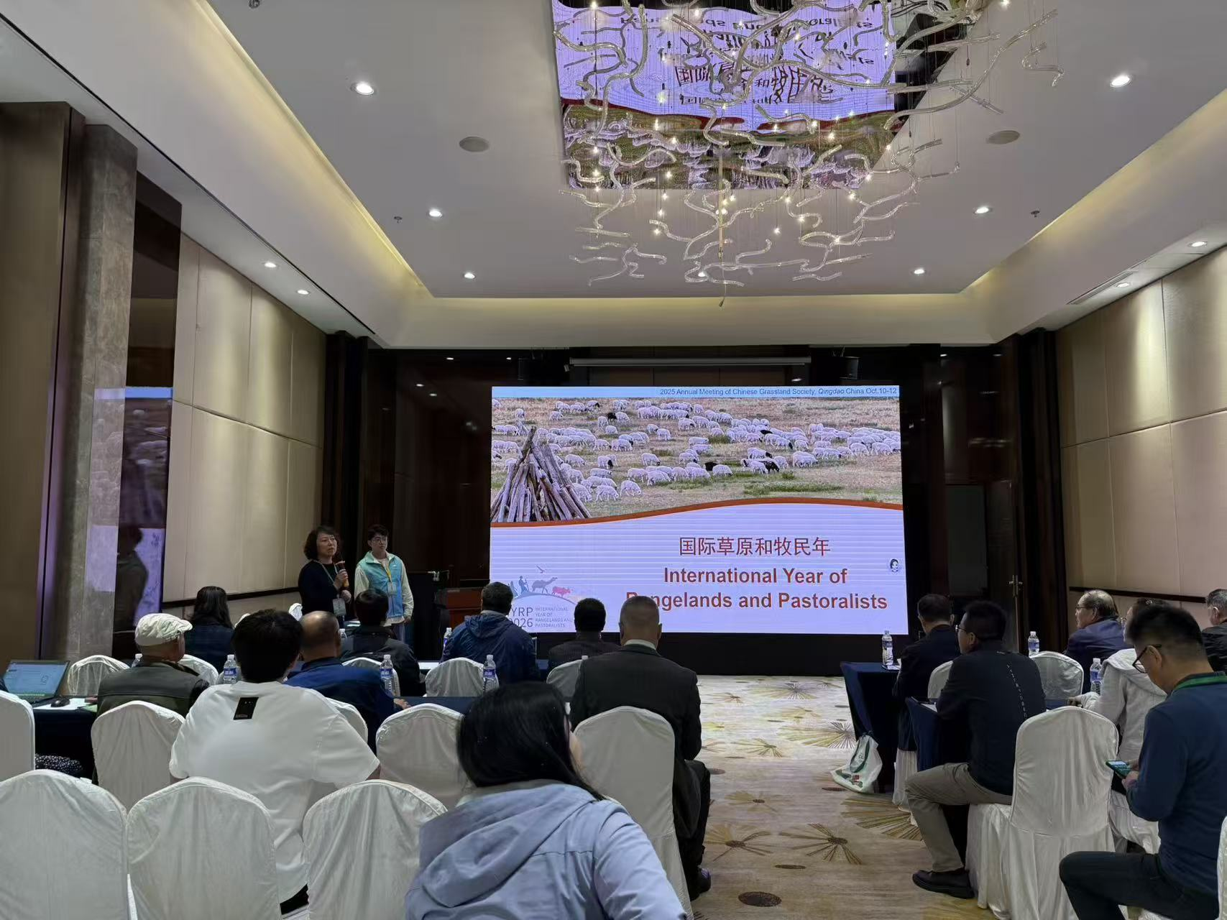
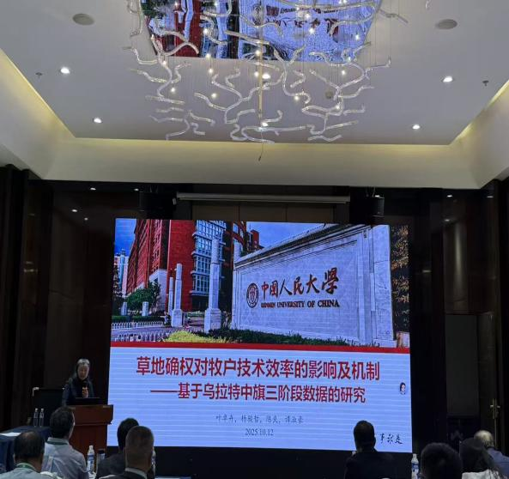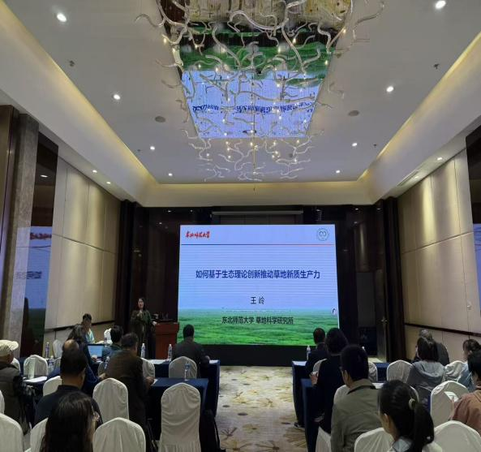

Prof. Han Guodong from Inner Mongolia Agricultural University, the convener of this session, delivered a keynote report that situated the International Year of Rangelands and Pastoralists within both natural and socio-economic contexts. He emphasized that grasslands constitute a tripartite ‘ecology-production-culture‘system, which needs to break through the one-way thinking of ’emphasizing protection over utilization‘ or ’emphasizing production over ecology‘-ecological protection needs scientific control (no grazing and rest, balance between grass and livestock), but it is necessary to ensure that herdsmen get stable income from protection. He identified that the current core tensions are the conflict between the rigidity of grass-livestock balance policy and the flexibility of pastoralists' production, an imbalance between the universal coverage and the targeted incentives of ecological compensation and award, and the disconnect between traditional nomadic culture and modern production. Prof. Han proposed three strategic pathways to address these challenges: ’dynamic grass-livestock balance‘(combining remote sensing and ground monitoring, annual adjustment of livestock carrying capacity), innovative ecological compensation (linking compensation with grassland restoration results, supporting ’ecology + cultural tourism/brand‘ to increase income), and integration of tradition and modernity (inheriting zoning rotational grazing technology and introducing Internet of Things monitoring). He shared a case study from Xilin Gol League featuring a ‘Cooperative-Led Stewardship’model. This approach has increased grassland vegetation coverage by 12-15% and raised the average annual income of participating households by 18,000 to 25,000 CNY.

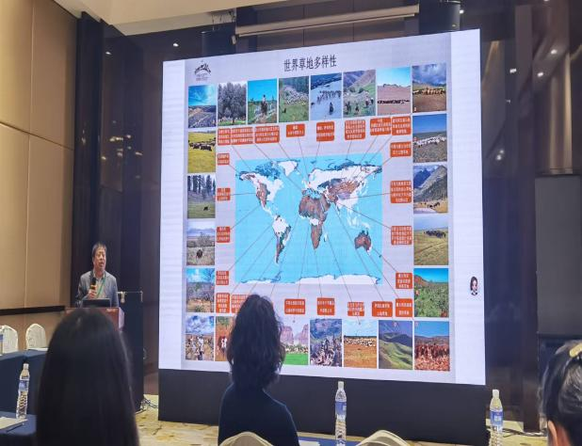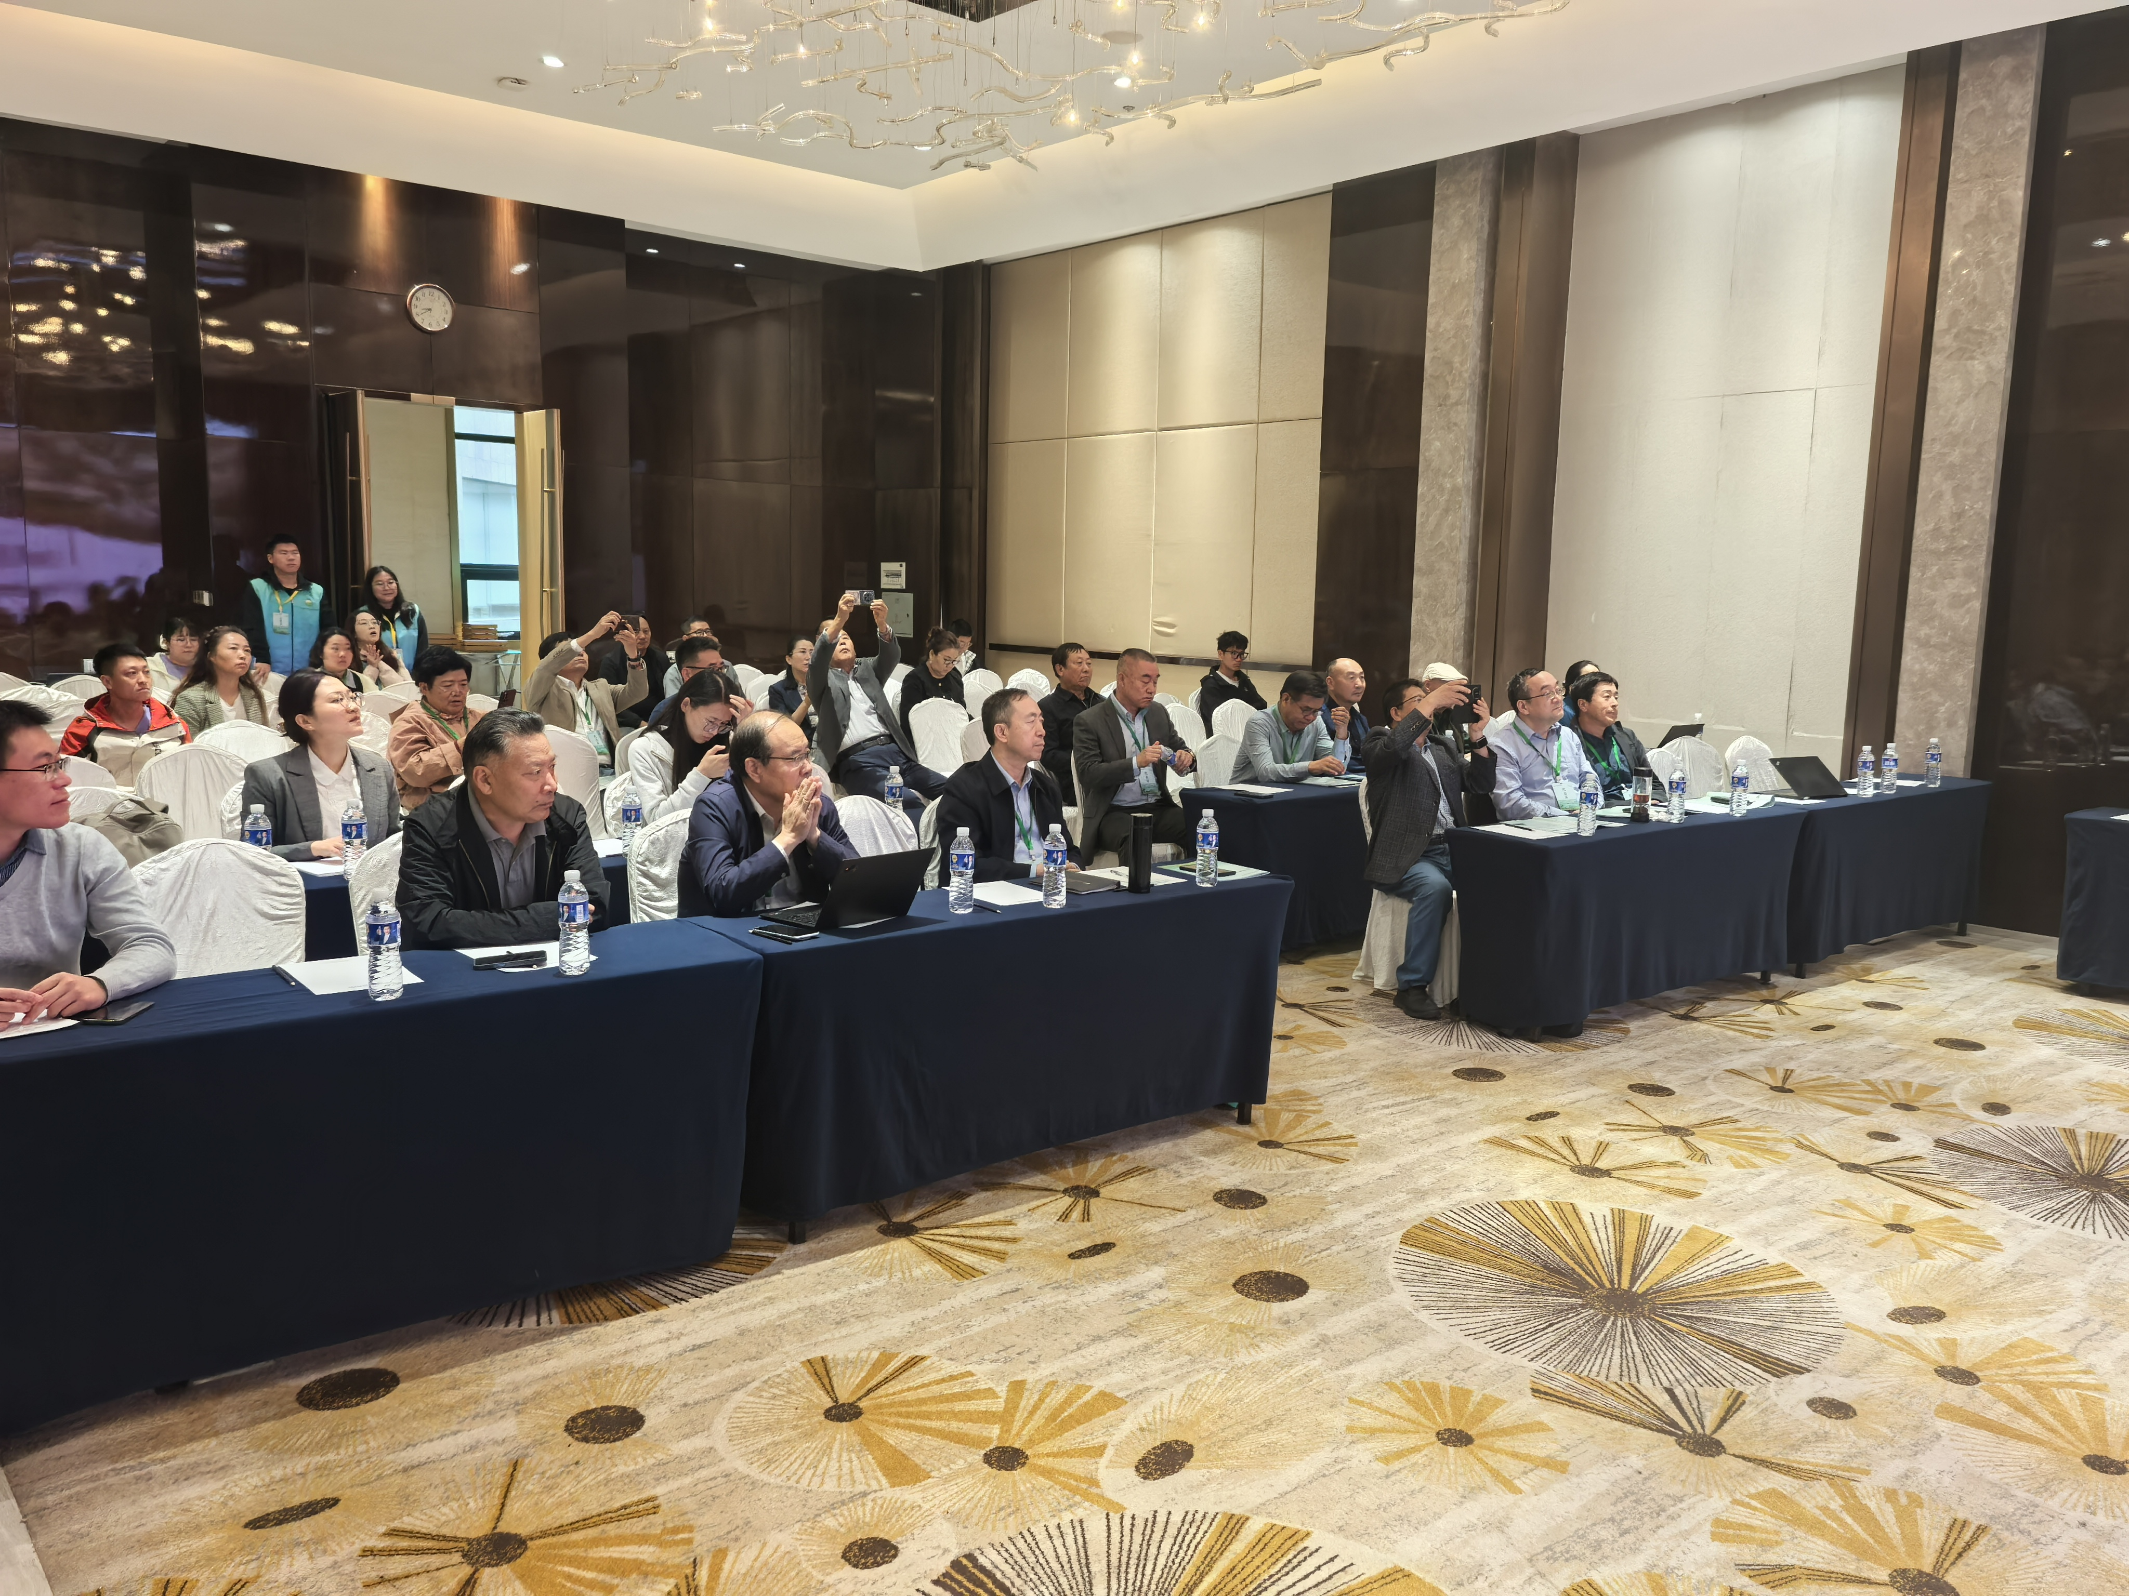
Roundtable Forum: Building Consensus and Drawing a Blueprint for the Development of Rangelands and Pastoralists
The academic reports were followed by a roundtable forum, chaired by Prof. Han Guodong at Inner Mongolia Agricultural University, and researcher Zebai, Ms. Yao Xueling, Bayas Huliang and grassroots herdsmen Bu He Chaolu, Fu Gang and Dorje Xiangjie were invited to participate in the roundtable forum. The forum held an in-depth dialogue around ‘Opportunities and Challenges for the Development of China's Rangelands and Pastoralists from an International Perspective’.
During the forum, Prof. Han Guodong stressed that China needs to play a leading role in East Asia, strengthen cooperation with Mongolia and other neighboring countries, and jointly promote grassland ecological protection and cultural heritage in combination with the preparatory progress of the International Year of Rangeland and Pastoralists. As grassroots pastoralists, Buhe Chaolu and Fu Gang shared their practical experiences in restoring grasslands and increasing incomes through methods like ‘less and intensive grazing’ and ‘mixed livestock grazing’ in Urad Middle Banner, Siziwang Banner and other places in Inner Mongolia, and proposed that it is necessary to further reduce the production and operation costs of herdsmen and improve the technology extension system. From the perspective of ethnic culture and younger-generation pastoralists, Zebai and Dorje Xiangjie advocated for greater recognition to the ecological wisdom of traditional nomadic culture in Qinghai-Tibet Plateau and other areas, promoting the integration of traditional knowledge and modern science and technology, and enhancing the dominant position of pastoralists in grassland management.

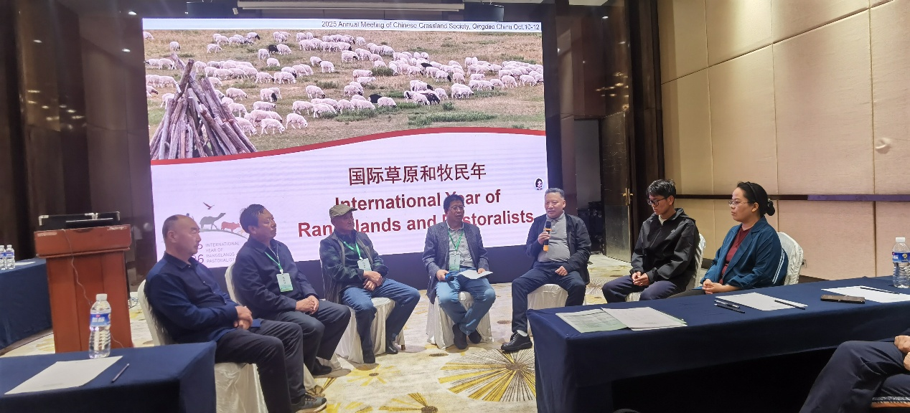

Participants agreed that the 2026 International Year provides a pivotal opportunity... and that future efforts should focus on four dimensions: Policy Coordination, Scientific & Technological Support, Community Engagement, and International Collaboration: First, optimize the balance of grass and livestock, ecological compensation and other policies, and establish a diversified investment mechanism; The second is to strengthen the scientific and technological research and development of grassland ecology and animal husbandry, and promote the landing of smart animal husbandry; Third, respect the dominant position of herdsmen, cultivate new business entities, and improve the interest linkage mechanism; The fourth is to deepen international exchanges and cooperation, share China's experience in grassland governance, and participate in the formulation of global grassland governance rules.
The successful convening of this session not only set up a platform for academic exchanges and experience sharing for experts in the grassland field, but also clarified the key direction of China's participation in the 2026 International Year of Grassland and Herdsmen. The delegates committed to leveraging this forum as a springboard to deepen research and enhance collaboration, contribute wisdom and strength to promoting the sustainable development of global grasslands and ensuring the livelihood and well-being of herdsmen, help the goals of the International Year of Grasslands and Herdsmen achieve results, and jointly protect grasslands, an important ecological and cultural treasure.
(Contributed by Dong Hao and Yao Xueling)

