Brussels InfoPoint conference on pastoralists
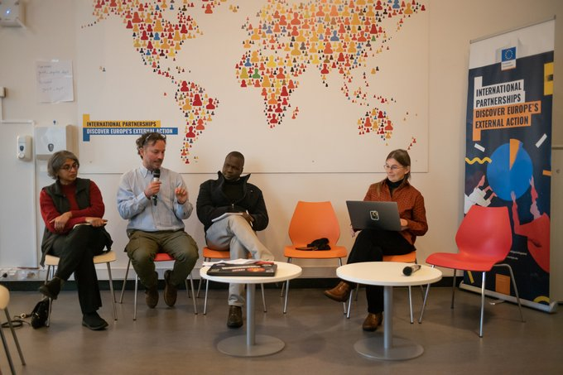
On 7 December 2022, a mini-conference on “Pastoralists, embracing uncertainty in a turbulent world” was held at the European Commission’s International Partnerships (INTPA) InfoPoint in Brussels, Belgium, in support of the IYRP 2026. The event was organised by the PASTRES (Pastoralism, Uncertainty & Resilience: Global Lessons from the Margins) research project funded by the European Research Council, VSFB (Vétérinaires Sans Frontières Belgium) and CELEP (Coalition of European Lobbies for Eastern African Pastoralism).
Pastoralism offers vital lessons for navigating highly variable environments. Pastoralists produce food and manage ecosystems, making use of rangelands that cover over half the land on Earth. Yet they are often dismissed as destructive, backward and in need of “modernisation”. Longstanding policy biases and negative narratives have shaped decision-making and investment in pastoral areas. A new approach is needed – informed by pastoralist knowledge and practice – to support pastoralist livelihoods, to defuse current conflicts, and to mitigate food and social insecurities. How can development and environmental programmes work together with pastoralist communities? The 1.5-hour conference addressed these issues, bringing perspectives on pastoralism in Europe, the Mediterranean area, Eastern Africa and South Asia.
Speakers were:
- Xavier Pavard, Policy Officer, INTPA F3- Sustainable Agri-Food systems and Fisheries
- Michele Nori, Socio-agronomist, European University Institute, Italy, and co-lead of PASTRES
- Nitya Ghotge, Veterinarian, writer & filmmaker, ANTHRA, India
- Emmanuel Emaruk, Uganda Country Director, VSF-Belgium
- Ann Waters-Bayer, Agricultural sociologist, Agrecol Association, Germany, member of the CELEP core group and the IYRP Global Coordinating Group.
At the beginning and end of the presentations, two 2-min films were shown:
- Pastoralism is the future: https://www.youtube.com/watch?v=DeqITzac9Ac
- International Year of Rangelands & Pastoralists: https://www.youtube.com/watch?v=zToSadWebwc&list=PLgz33fsrwiVkGSJE-I84wsKL8nOfRPdyU&t=31s
The video recording of the mini-conference can be found at the bottom of this webpage: https://international-partnerships.ec.europa.eu/news-and-events/events/infopoint-conference-pastoralists-embracing-uncertainty-turbulent-world-2022-12-07_en
The PPT presentation on the IYRP 2026 given by Ann Water-Bayer can be found here: https://www.iyrp.info/iyrp2026-presentation-brussels-7-dec-2022

