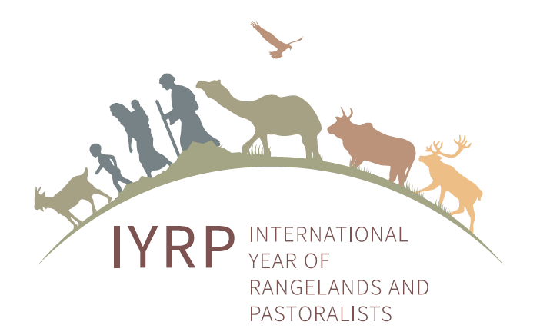
International Year of Rangelands and Pastoralists (IYRP):
Information for North American rangeland managers and enthusiasts

What is the IYRP?
In August 2019, the Government of Mongolia – a traditionally pastoralist country – proposed that the United Nations (UN) declare an International Year of Rangelands and Pastoralists (IYRP).
At the end of September 2020, the Committee on Agriculture (COAG) of the Food and Agriculture Organization (FAO) discussed the Mongolian proposal and on 2 October 2020, endorsed it for the celebration of the IYRP in 2026. The next hurdles that the proposal must pass are the FAO Council meeting in December 2020, the FAO Conference in July 2021 and finally the UN General Assembly in September 2021. Although a major milestone has been reached there is much urgency and opportunity for the three North American countries to show their decisive support for the UN designation of an IYRP.
Why was an IYRP proposed?
In its proposal, the Government of Mongolia argued that over half of the Earth’s land surface is rangeland: areas where the vegetation is made up of natural or naturalized grasses and shrubs that are grazed by livestock and wildlife. The productivity and environmental health of rangelands are critical for the livelihoods and cultures of more than 500 million pastoralists. Billions more non-pastoralists benefit from these areas through animal products, tourism, wildlife and biodiversity conservation, renewable energy, carbon sequestration, habitat for threatened and endangered species, and countless other ecosystem uses and services.
An IYRP will be celebrated to raise the profile of rangelands and increase recognition of how they contribute to the economy, environment, society and culture at a local, national and global level. An IYRP will raise awareness of the challenges and threats to rangeland sustainability. North American rangelands are ecosystems at risk due to invasive species, overuse, wildfire, cultivation, and climate change (as examples). The IYRP could call attention to the need for better policies at all levels of government to promote and enable rangeland health.
Who is and can be involved in the IYRP?
The Government of Mongolia drew up the proposal in partnership with national and international organisations including government bodies in several countries. Although North American governments have been slow to formally support an IYRP declaration there is increasing support from nongovernmental organizations and professional societies. The Society for Range Management (SRM) has stepped forward and will use its 2000 members and staff to act as the hub for activity within North America. The government of Canada supported the proposal at the COAG meeting, Mexico is likely to come on board with formal support soon, and the U.S. remains neutral. Livestock associations, conservation organizations, professional societies, wilderness advocates, and big game groups have all expressed solid support for the proposal.
The SRM has assembled a Taskforce charged with working to gain support for the Mongolian proposal. With the approval of the COAG now in place the proposal will move forward to the FAO next and eventually to the UN for a formal proclamation. Regional groups are being formed to plan and implement activities in the time leading up to and during the IYRP. Any organisations or individuals wanting to actively promote rangelands and pastoralists in their region or locale are welcome to join the relevant regional group(s). Livestock associations and conservation NGO’s are especially welcome to come together and promote rangeland stewardship.
Why is an IYRP important for North American rangelands and rangeland managers and enthusiasts?
- Increased respect for the achievements of rangeland managers in sustainably producing food and other products often in harsh and challenging environments that are unsuitable for other forms of food production.
- Facilitate a shift to view rangelands (50% of Earth’s surface) as a source of ecosystem services that need to be included in accounting for payment for ecosystem services programs, sustainable development goals and nationally determined contributions for climate change emissions reductions, giving low-forest-cover regions the ability to demonstrate their commitments to the UN climate change agreements.
- Recognize that rangelands are critical for achieving food and water security.
- Help establish programs to enhance environmental conditions of rangelands so they provide higher carbon sequestration potential, maintain biodiversity, and provide increased resilience to floods, fire, and drought.
- Prioritize the need to prevent conversion of native grasslands and rangelands to croplands as well as to increase rangeland productivity for livestock and wildlife, especially on privately held rangelands.
- Call attention to the need in both developed and developing countries for policies that manage rangelands sustainably, recognizing that they are coupled social and ecological systems with natural and cultural values.
- Boost efforts for investment in restoring and rehabilitating degraded rangelands, native grasslands and pasturelands.
- Increase capacities of local and national scientists and researchers to monitor and predict future trends in rangeland areas and to provide high-quality information to the people living in and managing rangelands to guide locally applicable best management practices.
- Showcase and strengthen rangeland pride in rural culture, especially among youth to promote intergenerational transfer of rangeland responsibility, ownership and management.
- Make rangeland and pastoralist organisations and networks more visible and provide a global platform to advocate for their rights to development, exchange knowledge and good practices, and reinforce cultural traditions and diversity.
What is happening when?
The focus of all groups now builds on the successful endorsement by the COAG. A website with brief information, statements, short video films and photos of pastoralists and rangelands has been developed. This will allow participants at higher levels of this process to see and hear pastoralists and learn about rangelands from different parts of the world.
Groups and individuals can add their voice to the proposal by immediately contacting:
Larry Howery (lhowery@ag.arizona.edu)
Barry Irving (birving@ualberta.ca)
They can advise you how to best direct your efforts. Time is of the essence to ensure this potentially invaluable project moves forward.
For more information, please see:
http://globalrangelands.org/international-year-rangelands-and-pastoralists-initiative

