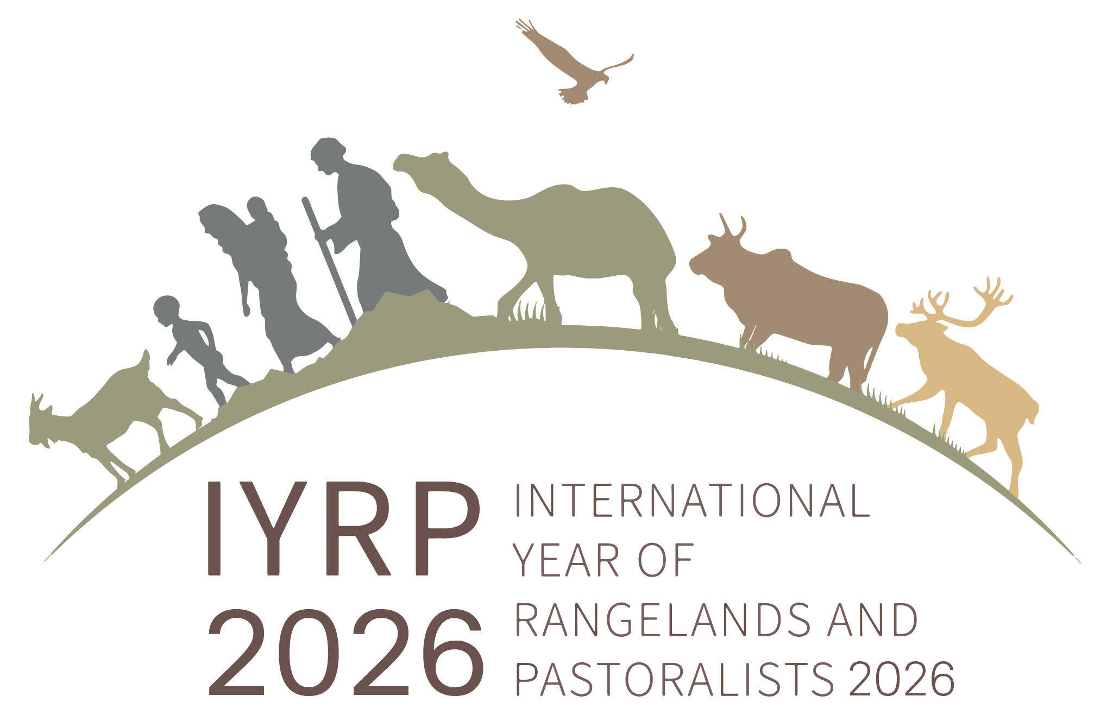
DRAFT sentences to be potentially added to UNCCD COP 15 decisions

Preamble sentence:

Recognizing that pastoralism is a dynamic and transformative livelihood linked to the diverse ecosystems, cultures, identities, traditional knowledge and historical experience of coexisting with nature, and that healthy rangelands are vital for contributing to economic growth, resilient livelihoods and the sustainable development of pastoralism, reaffirms that the observance of the International Year of Rangelands and Pastoralists in 2026 by the international community, approved by the UN General Assembly in March 2022, would contribute significantly to raising awareness of these issues of global concern.

Addition to Decision 10 (migration)

“ Recognizing that sustainable pastoralism has the potential to achieve land degradation neutrality by restoring degraded rangelands in many countries, achieving sustainable livelihoods for millions of pastoralists, and thereby reducing one of the causes of migration, requests the Secretariat, upon availability of resources a review of evidence on the potential benefits of sustainable pastoralism and rangeland ecosystem restoration for sustainable livelihoods, highlighting best practices and effective policies.”

Addition to Decision 11 (tenure)

“ Recognizing that sustainable pastoralism and land tenure security has the potential to achieve land degradation neutrality by restoring degraded rangelands in many countries and achieving sustainable livelihoods for millions of pastoralists, requests the Secretariat, upon availability of resources a review of evidence on the potential benefits of sustainable pastoralism and rangeland ecosystem restoration, highlighting best practices and effective land tenure policies.”

Addition to Decision 12 (drought)

“ Recognizing that pastoralists have traditional and modern mechanisms for adapting to and living with drought and climate variability, and that these mechanisms have the potential to achieve land degradation neutrality by restoring degraded rangelands in many countries and achieving sustainable livelihoods for millions of pastoralists, requests the Secretariat, upon availability of resources, to provide evidence on the role of sustainable pastoralism in responding to drought, restoring degraded rangelands and achieving land degradation neutrality.”

